Year 6 Week 5 – Home Learning
Challenge 1 | Challenge 2 | Challenge 3
It has come to the time of year when we need to start thinking about you leaving Primary School to embark on your next chapter of High School.  Normally we would be talking to your new teachers and telling them lots about all of you.  We still would really like to let your new schools know about you all and give them some information about each and every one of you!  Please can you think of some things you would like your new teachers to know about you this could be your favourite hobbies, your likes and dislikes or anything that is important to you.  Please could you make a list of these things and ask your parents to email them over to us for us to read through and share with your new school which we are certain they will love to read. | We are all currently living through very strange times which one day will definitely turn up in the history books! We would love you to write a letter to your future selves which you can look back on in years to come thinking about; how life has changed for you, how you are feeling, things you have been grateful for in these strange times and what you have missed the most.  We have included an example of a time capsule on the Year 6 home learning page for you to complete. You can either print this out or create your own. There is even an activity where you can interview your own family!!  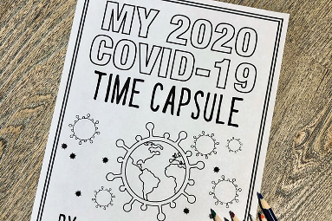 | Your final challenge is to design your own garden imagining there is no limit on your budget. We are sure lots of you have been spending more time outside and think it would be a fun activity to design your very own garden. You could research different types of plants, vegetables and flowers that you could plant in your garden. You could even include measurements of how big you would like your garden to be and the different sizes of areas in your garden. Remember to be sensible with the size of your garden and not make it the size of Birkenhead Park!! You can research different designed gardens and use some of the ideas from them to create your own dream outdoor space.  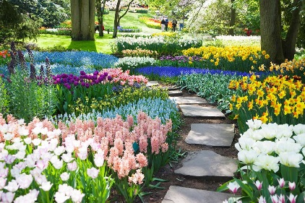
We hope this activities keep you busy over the next week. Stay safe Year 6 and we really hope to see you all soon.

