Year One Challenges Week 10
English: We hope you enjoyed the story of the Singing Mermaid last week! This week we would like you to look at the book/listen to the story online again and see if you can notice some rhyming words. When words rhyme they sound the same eg cat and hat, pig and dig. How many pairs of rhyming words can you find in the story? Ask a grown up to help you write some of them down and notice which letters are the same in both of the rhyming words eg cat, hat and pig, dig. Make a list of words that rhyme with these:
ring way fill dog
Now can you use two of your rhyming words to write silly sentences? Eg The cat had a new hat. The pig likes to dig.

Maths: This week we are thinking about position, direction and movement.The mermaid was kept in a tank and she rode on a horse. Can you use one of your toys to show your grown up that you know what all these words mean?
on top of next to underneath near between in front of
behind on the left of on the right of

Then have a look around your house and garden and see how many things you can find that move in these ways:
forwards and backwards left to right (or right to left)
up and down round and round
Draw pictures to show what you found!

Science: We have been learning about materials and this week we would like you to find out what the word waterproof means. Can you think of anything that needs to be waterproof? Can you find some different materials eg paper, a towel, silver foil, a plastic bag and think of a test you could do to see if they are waterproof. https://www.youtube.com/watch?v=CSs0ogUUqdM shows a simple test you could do. Now draw pictures of objects that need to be waterproof.
Art: Have a look online at Red Ted Art and try making yourself a paper plate mermaid twirler
https://www.redtedart.com/paper-plate-mermaid-twirler/.
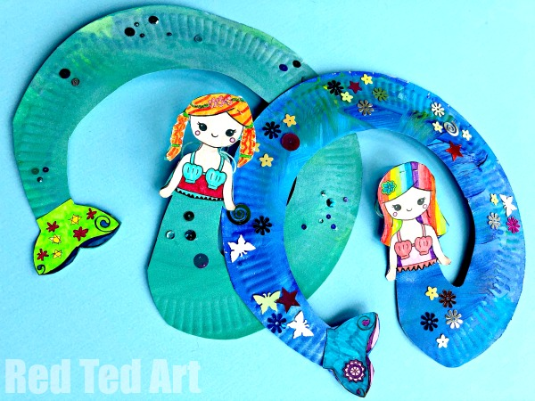

Finally:
Don’t forget to keep reading and practicing your Phonics too!
BBC Bitesize Phonics Phase 3 has lots of short video clips to remind you of the sounds we have learned and games to help you practice them too.
Have a lovely week and make sure you stay safe!

