Year 2 Autumn Term
Science  A Force is a push or pull acting on an object.  When an object is placed in water it can float or sink.  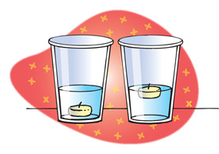  Gravity is a force that tries to pull objects towards each other. Earth’s gravity is what keeps you on the ground and causes objects to fall.  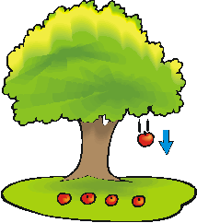  What does a seed need to grow? How do plants stay healthy?  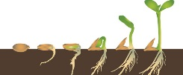 | History  In 1888 William Lever built a new factory on the Wirral.  He built Port Sunlight to give his factory workers a better life.  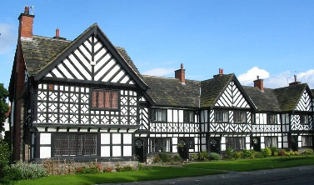  William Lever built the Lady Lever Art gallery in 1922 in memory of his wife.  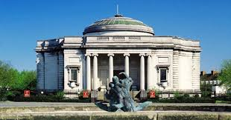 | Geography  I live in Europe.  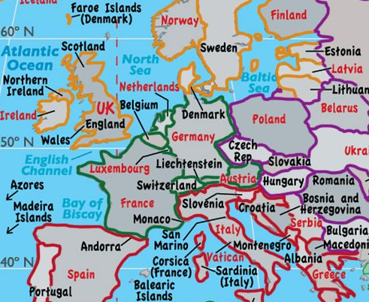  The Republic of Ireland, France, Germany, Spain and Italy are countries in Europe.  Each country has a capital city.  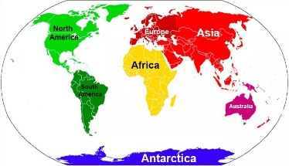  There are seven continents and five oceans in the world. | Art  A study of Wedgewood pottery. Observing, designing and making own pots.  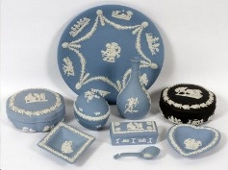  Comparing Wedgewood with Della Robbia made in Birkenhead.  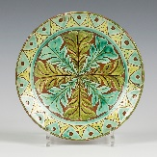  Compare materials, colour and design. | DT  What makes the perfect sandwich?  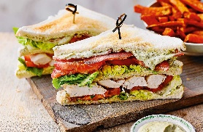  Taste ingredients from the European countries of France, Germany, Spain and Italy.  Design, make and taste a selection of sandwiches

