Year 5 Week 13 challenges
Please share your learning with us on our Facebook and Twitter pages: we love seeing all the different things you are getting up to!
Year 5 cook book  Using cook books or even the internet find a recipe that you would like to use to get creative in the kitchen. You will need to read the instructions carefully in order to make the food. Can you create you own receipe and set of instructions for your faveourite meal?  Why not send you receipes and set of instructions to us and we can create a Year 5 Cookbook of all the different things you have enjoyed making whislte being away from school. 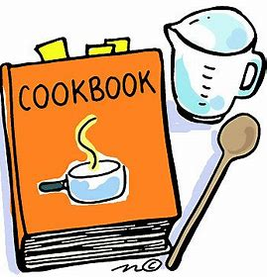 | Spelling Challenge  BEAT THE PARENTS!  Choose different items you have in the house or that you know to name to and spell e.g. Spatula or courgette. REMEMBER – DON’T MAKE IT TOO EASY FOR THEM!  First one to twelve wins!  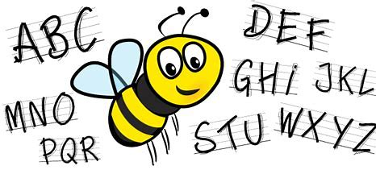 | Geography  Compare and contrast  Compare Britain you live in today to one of the country in the former British empire.  Traditions  Food  Culture  Currency  When you are older which country would you prefer to live in and why?  