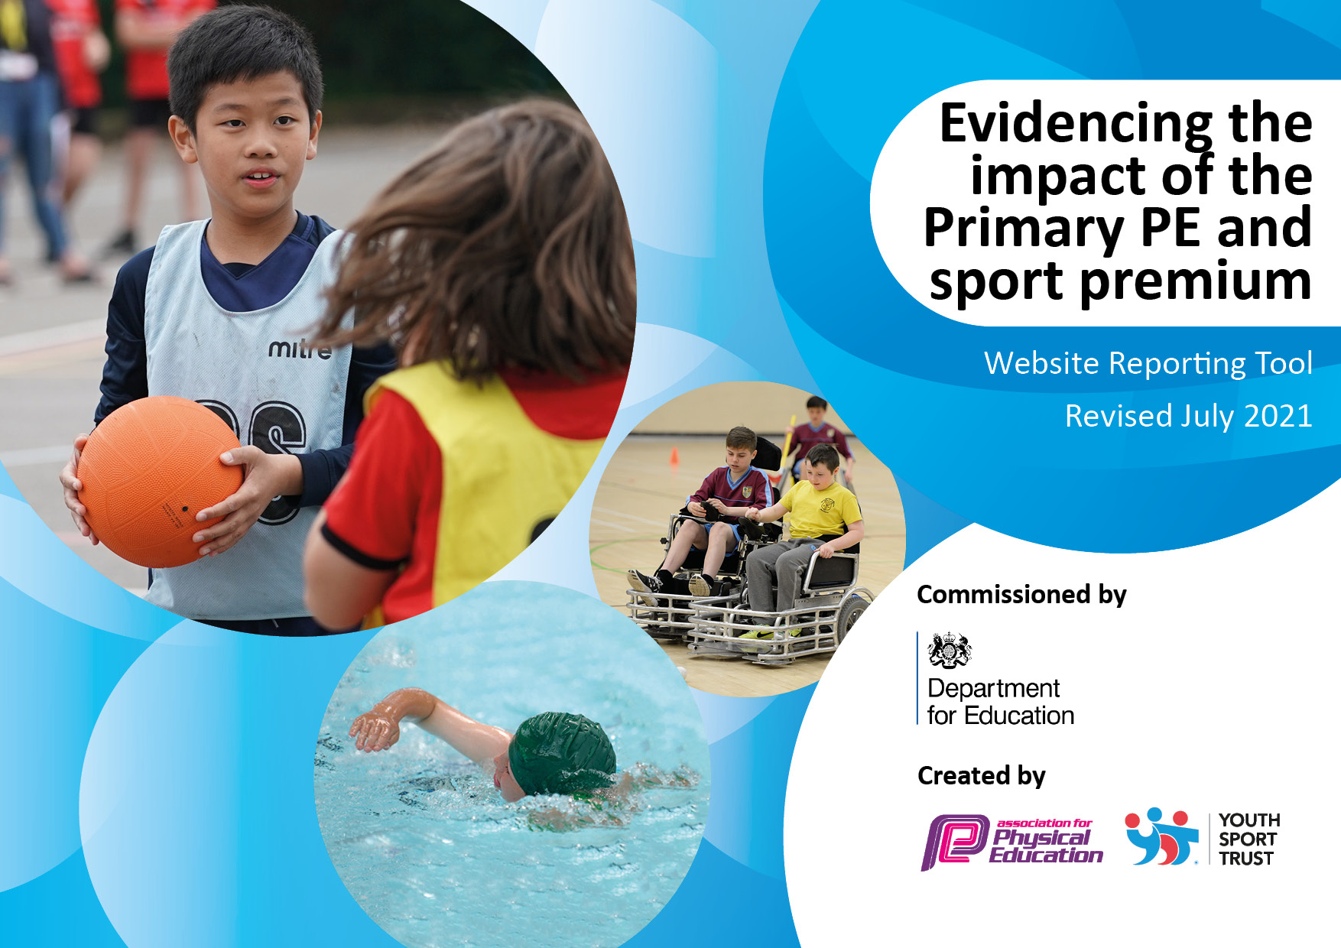
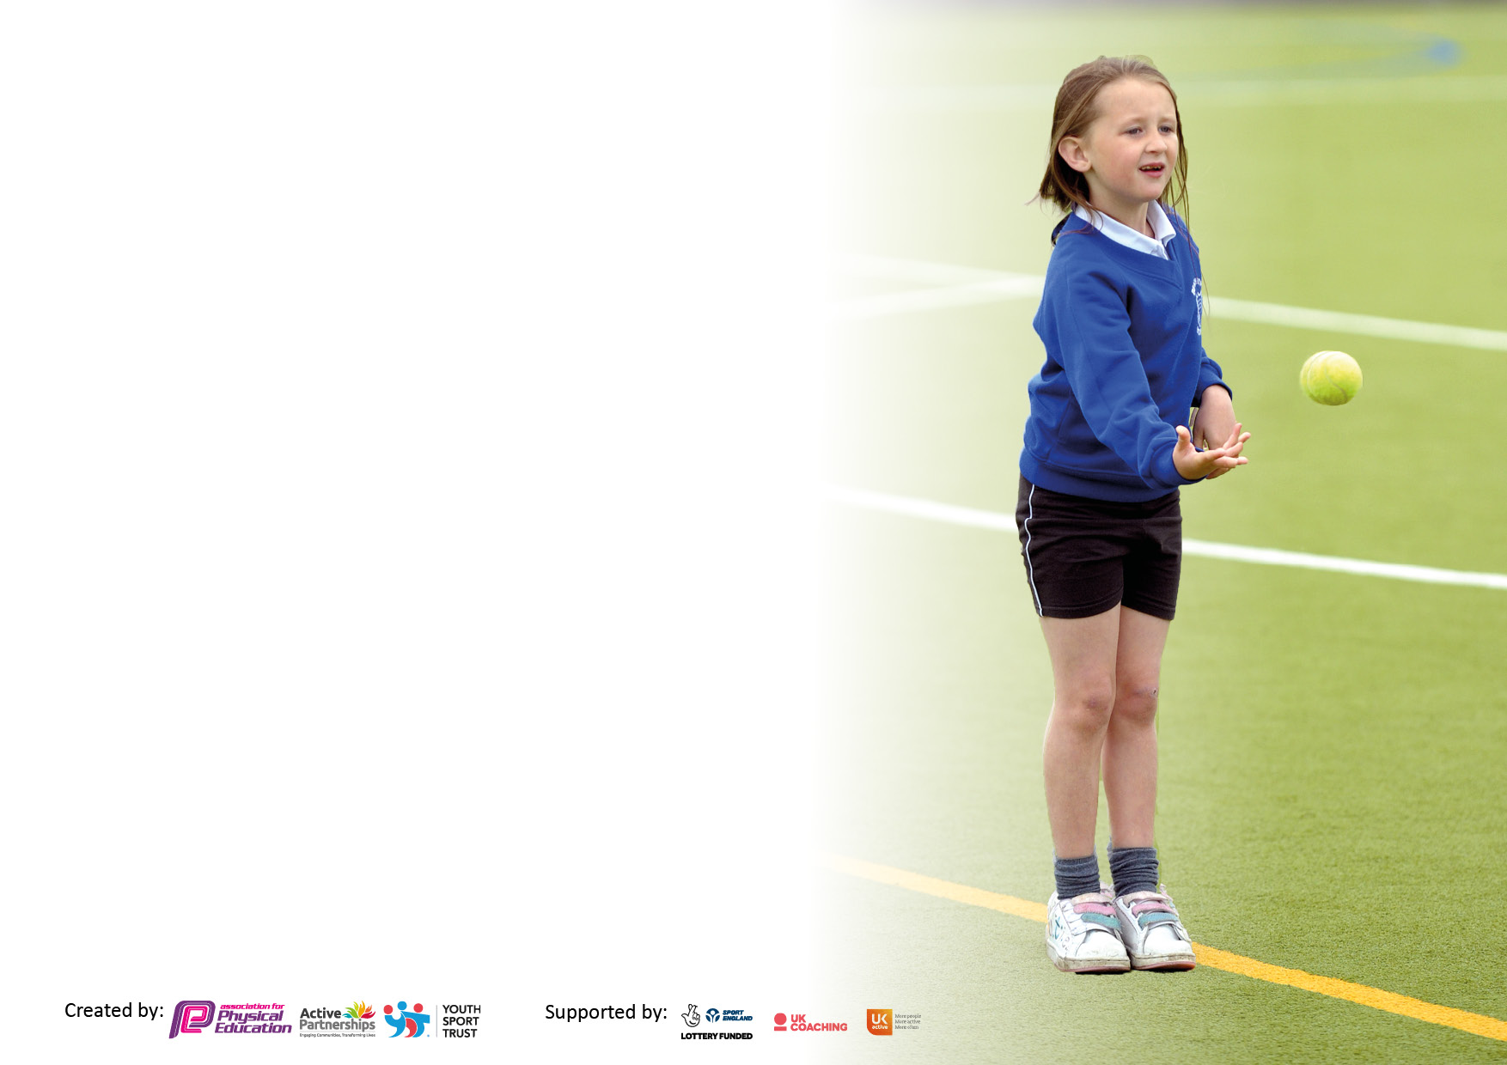

It is important that your grant is used effectively and based on school need. The Education Inspection Framework makes clear there will be a focus on ‘whether leaders and those responsible for governors all understand their respective roles and perform these in a way that enhances the effectiveness of the school’.

Under the Quality of Education Ofsted inspectors consider:
Intent - Curriculum design, coverage and appropriateness
Implementation - Curriculum delivery, Teaching (pedagogy) and Assessment
Impact - Attainment and progress

To assist schools with common transferable language this template has been developed to utilise the same three headings which should make your plans easily transferable between working documents.

Schools must use the funding to make additional and sustainable improvements to the quality of Physical Education, School Sport and Physical Activity (PESSPA) they offer. This means that you should use the Primary PE and sport premium to:

- Develop or add to the PESSPA activities that your school already offer
- Build capacity and capability within the school to ensure that improvements made now will benefit pupils joining the school in future years
- The Primary PE and sport premium should not be used to fund capital spend projects; the school’s budget should fund these.

Pleasevisitgov.ukfortherevisedDfEguidanceincludingthe5keyindicatorsacrosswhichschoolsshoulddemonstrate animprovement.Thisdocumentwillhelpyoutoreviewyourprovisionandtoreportyourspend.DfEencouragesschools to use this template as an effective way of meeting the reporting requirements of the Primary PE and sport premium.

We recommend you start by reflecting on the impact of current provision and reviewing the previous spend.

Schools are required to publish details of how they spend this funding, including any under-spend from 2019/2020, as well as on the impact it has on pupils’ PE and sport participation and attainment. All funding must be spent by 31st July 2022.

We recommend regularly updating the table and publishing it on your website throughout the year. This evidences your ongoing self-evaluation of how you are using the funding to secure maximum, sustainable impact. Final copy must be posted on your website by the end of the academic year and no later than the 31st July 2021. To see an example of how to complete the table please click HERE.

Details with regard to funding
Please complete the table below.

Total amount carried over from 2019/20 | £0
Total amount allocated for 2020/21 | £0
How much (if any) do you intend to carry over from this total fund into 2021/22? | £0
Total amount allocated for 2021/22 | £19,580
Total amount of funding for 2021/22. To be spent and reported on by 31st July 2022. | £28,164.98
Swimming Data
Please report on your Swimming Data below.

Meeting national curriculum requirements for swimming and water safety.  N.B. Complete this section to your best ability. For example you might have practised safe self-rescue techniques on dry land which you can then transfer to the pool when school swimming restarts.  Due to exceptional circumstances priority should be given to ensuring that pupils can perform safe self rescue even if they do not fully meet the first two requirements of the NC programme of study | 54% - Data from Spring Term Swimming\Our Lady and St Edward's Catholic Primary School_ Swimming Report Autumn.pdf
What percentage of your current Year 6 cohort swim competently, confidently and proficiently over a distance of at least 25 metres?  N.B. Even though your pupils may swim in another year please report on their attainment on leaving primary school at the end of the summer term 2020.  Please see note above | 54%
What percentage of your current Year 6 cohort use a range of strokes effectively [for example, front crawl, backstroke and breaststroke]?  Please see note above | 54%
What percentage of your current Year 6 cohort perform safe self-rescue in different water-based situations? | 54%
Schools can choose to use the Primary PE and sport premium to provide additional provision for swimming but this must be for activity over and above the national curriculum requirements. Have you used it in this way? | Yes/No

Action Plan and Budget Tracking
Capture your intended annual spend against the 5 key indicators. Clarify the success criteria and evidence of impact that you intend to measure to evaluate for pupils today and for the future.

Academic Year:2021/2022 | Total fund allocated: £19,580 | Date Updated:
Key indicator 1: The engagement of all pupils in regular physical activity – Chief Medical Officers guidelines recommend that primary school pupils undertake at least 30 minutes of physical activity a day in school |  |  |  | Percentage of total allocation:
 |  |  |  | %
Intent | Implementation |  | Impact
Your school focus should be clear what you want the pupils to know and be able to do and about  what they need to learn and to  consolidate through practice: | Make sure your actions to achieve are linked to your intentions: | Funding allocated: | Evidence of impact: what do pupils now know and what can they now do? What has changed?: | Sustainability and suggested next steps:
Chn to feel confident in using a range of different equipment. Chn to feel inspired to participate in physical activity. | Chn to use equipment to participate in organised physical activity during playtime and lunch times. | £362.98 | % of children participating in Autumn Term = ≤20 % of chn  Spring Term = ≤50 % of children  Summer Term = 65% of children | Sports Leaders across KS2 to support and set up organised physical activity on playground.
Wirral School Games – Engaging children in participating in new sports. | Identified children are to attend events focused on increased participation across a range of sports. | £0 | Children attended 3 Wirral School Games events. Including cricket and taekwondo. | Continue to develop working relationship with WSG. Increased participation across more year groups, including EYFS.
Key indicator 2: The profile of PESSPA being raised across the school as a tool for whole school improvement |  |  |  | Percentage of total allocation:
 |  |  |  | %
Intent | Implementation |  | Impact
Your school focus should be clear what you want the pupils to know and be able to do and about  what they need to learn and to  consolidate through practice: | Make sure your actions to achieve are linked to your intentions: | Funding allocated: | Evidence of impact: what do pupils now know and what can they now do? What has changed?: | Sustainability and suggested next steps:

Key indicator 3: Increased confidence, knowledge and skills of all staff in teaching PE and sport |  |  |  | Percentage of total allocation:
 |  |  |  | %
Intent | Implementation |  | Impact
Your school focus should be clear | Make sure your actions to | Funding | Evidence of impact: what do | Sustainability and suggested
what you want the pupils to know | achieve are linked to your | allocated: | pupils now know and what | next steps:
and be able to do and about | intentions: |  | can they now do? What has
what they need to learn and to |  |  | changed?:
consolidate through practice:
Staff members to be confident in the content and delivery of their lessons. | Purchase of Edsential Scheme of Work. | £240 | What % of staff feel more confident when using SoW?  - 100%  What % of staff feel they have more awareness of the PE NC after using SoW?  - 100% | Continue to purchase SoW.
Curriculum Design Meeting alongside Edsential.  Supporting subject leader in reflecting on the current curriculum and ensuring the future curriculum meets the needs of the school. | Curriculum Design Meeting.  ½ day subject leader meeting to establish the curriculum Intent, Implementation and Impact. Use of curriculum mapping tool to identify priorities, gaps in provision and to write a curriculum vision Design and printing of a curriculum map poster | £720 | Termly visits to support Subject  Leader, including support with monitoring.  Increased confidence and awareness of subject leader. | Use of Curriculum Map across the school.  Identify assessment areas from the Curriculum Map.  Use of CM to create and implement detailed Long Term Plan and Medium Term Plan.
To ensure subject leader is able to implement and support PE across the school | Subject Leader Support | £810 | Increased confidence and awareness of subject leader. | Identify areas of support leading into Sept 2022/2023.
Employment of Sports Assistant (SA)  To enhance the quality of PE for all pupils during timetabled curriculum PE lessons.  Increased opportunities for enhanced and enjoyable outdoor activities during after school club | SA will provide additional support, expertise and skills, working alongside the class teacher. The additional support will enable pupils to improve their progress, attainment and confidence within lessons. | £20,000 | Pupils to increase enjoyment and understanding during PE lessons.  Preparation of equipment has ensured maximum use of lesson time.  Staff supported in areas of low confidence throughout lesson. Opportunities to Team teach within lesson time. | Use of Sports Assistant across school alongside Subject Leader 2022/2023.
Key indicator 4: Broader experience of a range of sports and activities offered to all pupils |  |  |  | Percentage of total allocation:
Intent | Implementation |  | Impact
Your school focus should be clear | Make sure your actions to | Funding | Evidence of impact: what do | Sustainability and suggested
what you want the pupils to know | achieve are linked to your | allocated: | pupils now know and what | next steps:
and be able to do and about | intentions: |  | can they now do? What has
what they need to learn and to |  |  | changed?:
consolidate through practice:
Chn to receive extra swimming sessions to support loss of learning through COVID-19 | Purchase of 2 weeks of extra swimming sessions. | £3132 | 54% Year 6 children have passed their swimming targets. | Continuity of Swimming. Swimming to be attended Y3-Y.
Creating links with local area focusing on giving children to opportunity to access a variety of sports. Chn to be given opportunity to find sports which may inspire them to participate in life-long physical activity. | Contact local sports clubs to arrange taster sessions within school. | £800 | Discussion with Local clubs –Children attended various events. Including cricket, taekwondo and football. | Continue to work alongside local schools and clubs to increase participation across a variety of sports.
Key indicator 5: Increased participation in competitive sport |  |  |  | Percentage of total allocation:
 |  |  |  | %
Intent | Implementation |  | Impact
Your school focus should be clear | Make sure your actions to | Funding | Evidence of impact: what do | Sustainability and suggested
what you want the pupils to know | achieve are linked to your | allocated: | pupils now know and what | next steps:
and be able to do and about | intentions: |  | can they now do? What has
what they need to learn and to |  |  | changed?:
consolidate through practice:
Creating increased opportunities for chn to participate through arranging transport to/from competitive activities. | Money to be set aside to pay for transport inc. minibus/coach/taxi. | £ 1,500 | Minibus hire has ensured Children attended events across KS2. Including cricket and taekwondo. | Increase participation within KS1.
Enhance mental and physical development, social skills and even improvements in academic performance.  2. Children to learn how to cope in a competitive environment. | Children to compete and participate in Sports Day | £0 | All children across the school participated in sports day. | Continue to develop sports day to include a variety of events.

Signed off by
Head Teacher:
Date:
Subject Leader:
Date:
Governor:
Date:

