¿Qué quieres? (What would you like?)

Quiero un zumo de manzana. ¿Y tú? (I would like an apple juice. What would you like?)

[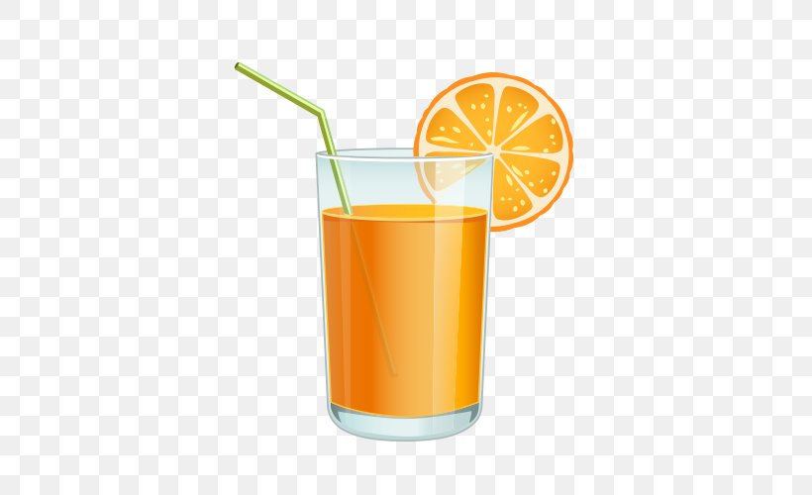](https://www.google.co.uk/url?sa=i&url=https%3A%2F%2Ffavpng.com%2Fpng_view%2Fjuice-orange-juice-clip-art-png%2FbGRL4ny9&psig=AOvVaw0HAisz9SXRDwVmmkYqoLeo&ust=1587575280457000&source=images&cd=vfe&ved=0CAIQjRxqFwoTCPj2nf-A-ugCFQAAAAAdAAAAABAD)

Quiero…(I would like…)

¿Qué quieres? (What would you like?)

Por favor (please)

una limonada (a lemonade)

un agua mineral (a mineral water)

un zumo de naranja (an orange juice)

un zumo de manzana (an apple juice)

un chocolate caliente (a hot chocolate)

During the Summer Term, Year 1 children will revise vocabulary from the first two terms and will then move onto listening to/reading a well-known English story in Spanish ‘Brown Bear, Brown Bear, What Do You See?’ They will be introduced to some ‘Drinks’ vocabulary and learn how to order a drink in Spanish, stating their preferences.

un oso marrón (a brown bear)

un pájaro rojo (a red bird)

un pato amarillo (a yellow duck)

un caballo azúl (a blue horse)

una rana verde (a green frog)

un gato morado (a purple cat)

un perro blanco (a white dog)

una oveja negra (a black sheep)

un mono marrón (a brown monkey)

niños (children)

**Year 1 Knowledge Organiser Summer Term Spanish**

