**Year 5 Knowledge Organiser Summer Term**

**Spanish**

**Useful Weather Phrases**

En verano la gente va a la playa (In summer people go to the beach)

En otoño está nublado (In autumn it’s cloudy)

En invierno hace mucho frío (In winter it’s very cold)

En primavera la gente va de picnic (In spring people go for a picnic)

Following on from their ‘Weather’ work in Year 4, Year 5 children will begin to describe what the weather is like in each of the four seasons. They will access new texts and will read aloud phrases from a poem. They will write short phrases using rhyming words. To support their existing Year 5 knowledge about ‘Earth and Space’ in Science, children will spend the second half of the term focusing on vocabulary linked to ‘The Planets’.

**Important Vocabulary**

Las estaciones (Seasons)

el otoño (autumn)

el invierno (winter)

la primavera (spring)

el verano (summer)

¿Qué tiempo hace? (What’s the weather like?)

¿Qué estación / mes prefi eres? (Which season/month do you prefer?)







[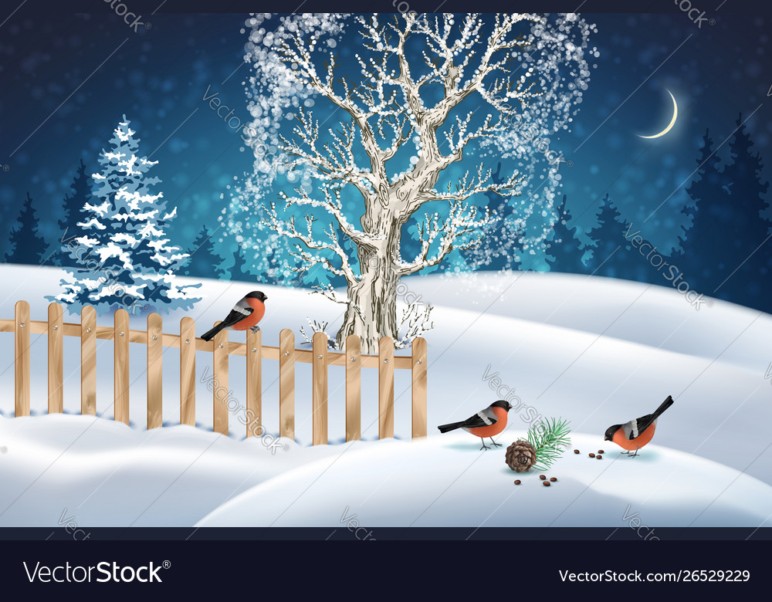](https://www.google.co.uk/url?sa=i&url=https%3A%2F%2Fwww.vectorstock.com%2Froyalty-free-vector%2Fchristmas-winter-scene-vector-26529229&psig=AOvVaw1O7KNKai1pc4mUnLgMMmNO&ust=1587545905838000&source=images&cd=vfe&ved=0CAIQjRxqFwoTCICwxcCT-egCFQAAAAAdAAAAABAD)