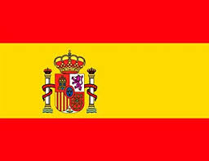[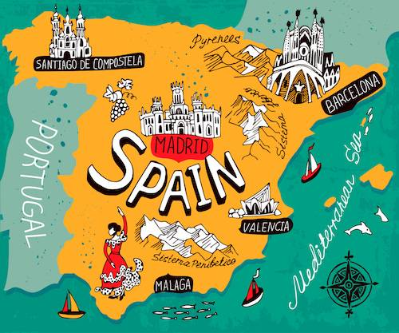](https://www.google.co.uk/url?sa=i&url=https://www.kids-world-travel-guide.com/spain-facts.html&psig=AOvVaw0VTK7FYIp8nVxWrm8wvCQX&ust=1587477777360000&source=images&cd=vfe&ved=0CAIQjRxqFwoTCKC3lN-V9-gCFQAAAAAdAAAAABAD)

**Numbers 1-20**

1= uno

2 = dos

3 = tres

4 = cuatro

5 = cinco

6 = seis

7 = siete

8 = ocho

9 = nueve

10 = diez

11 = once

12 = doce

13= trece

14 = catorce

15 = quince

16 = dieciséis

17 = dieciseite

18 = dieciocho 30= treinta

19 = diecinueve 40= cuarenta

20 = veinte 50= cincuenta

**Classroom Commands:**

escucha, escuchad (Listen)

mira, mirad, (Look)

siéntate, sentaos, (Sit down)

levántate, levantaos (Stand up)

During the Autumn Term, Year 3 children will discuss where Spanish is spoken and will great each other in Spanish. They will learn to count up to at least 50, say their age and understand simple classroom commands.

**Did you know?**

* **The Spanish name for Spain is** España
* **Spain is located in Europe**
* **It is a developed country with a high quality of life**
* **The largest city and capital of Spain is Madrid**

**Year 3 Knowledge Organiser Autumn Term**

**Spanish**

[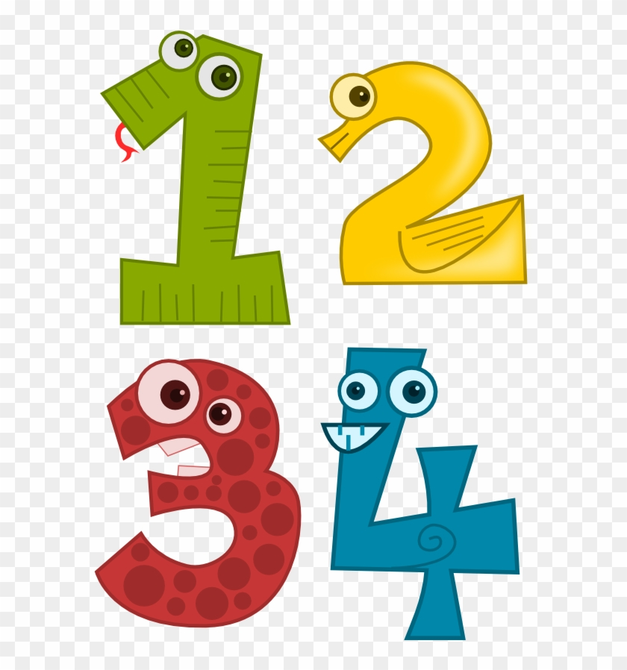](https://www.google.co.uk/url?sa=i&url=https%3A%2F%2Fwww.clipartmax.com%2Fmiddle%2Fm2H7H7Z5N4m2A0G6_print-colourful-numbers-1-20%2F&psig=AOvVaw2bGlRa7vZz2c4w1vfs6kV4&ust=1587479795583000&source=images&cd=vfe&ved=0CAIQjRxqFwoTCPCO7KKd9-gCFQAAAAAdAAAAABAD)

**Important Vocabulary**

* Hola; adiós; hasta luego
* ¡Buenos días! ¡Buenas tardes! ¡Buenas noches! (Greetings)
* ¿Cómo te llamas? (What is your name?) Me llamo ….
* ¿Qué tal? (How are you?) Bien, muy bien, regular, mal, fatal, fenomenal