Our Lady and St Edwards Knowledge Organiser | Year 3 - Art | Autumn | Cave Art
Key Facts about the Artist |  | Key Vocabulary and important Facts
Name: Banksy  Life: 1974 (age 46 years)  Country of Birth: Bristol, England  Style: Wall Art  Period: Modern Art  Media: Paint and Print Making  Banksy is a British street and graffiti artist. He likes to remain anonymous and not let people know his true identity. He often draws in high visibility public places such as on buildings or train stations. His paintings are often about politics, war and other important topics. |  | Street Art – artwork that is created in a public space, typically without official permission.  Graffiti – writing or drawings scribbled, scratched, or sprayed illicitly on a wall or other surface in a public place.  Mineral Pigments – A mineral material used to give colour, or body to a paint.  Stencils – a thin sheet of card, plastic, metal with a pattern cut out of it or the outline of an object used in the application of ink or paint through the holes or around the edge.  Printmaking – the making of pictures or designs by printing them from specially prepared plates or blocks.  Prehistoric Art – Cave art, generally, the numerous paintings and engravings found in European caves and shelters dating back to the Ice Age  Modern Art - art that was created between the late 19th and the late 20th centuries.
Prehistoric Art |  | Books, internet sites and places to visit
Cave paintings are a type of prehistorical art, found on the wall or ceilings of caves.  Most cave paintings were of animals or hunters. A cave could be full of many paintings by many different painters. Many hand stencils have also been discovered.  Some of the most impressive cave paintings have only been found in the last 100 years. There could be more out there we don’t know about!  They used natural colours from mineral pigments.  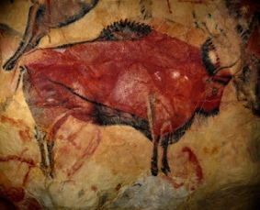  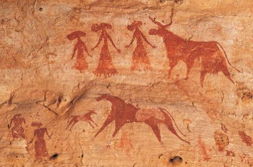 |  | https://www.bbc.co.uk/bitesize/clips/zsghdmn  https://kids.kiddle.co/Banksy  https://www.twinkl.co.uk/resource/t2-t-346-banksy-powerpoint  https://www.twinkl.co.uk/resource/t2-h-431-stone-age-cave-paintings-photo-powerpoint  https://www.twinkl.co.uk/resource/t2-h-465-stone-age-cave-paintings-photo-flipchart  https://www.ks2history.com/cave-art  https://www.kapowprimary.com/subjects/art-design/lower-key-stage-2/year-3/prehistoric-art/  Stone Age Boy Book

