

During the Autumn term, Year 4 children will create and perform a dialogue about the weather. They will understand that Spanish is spoken in many different countries. Children will begin to write sentences from memory, expressing opinions about what they like/do not like to do.

Mi tiempo libre (My spare time)

Qué te gusta hacer? (What do you like to do?)

Me gusta (I like)

no me gusta (I don’t like)

me encanta (I love)

odio (I hate)

prefiero (I prefer)

Tocar el piano (playing the piano)

jugar al fútbol (playing football)

montar en bici (cycling)

**Year 4 Knowledge Organiser Autumn Term**

**Spanish**





**Did you know?**

The Olympic Games were held in Spain (Barcelona) in 1992.

[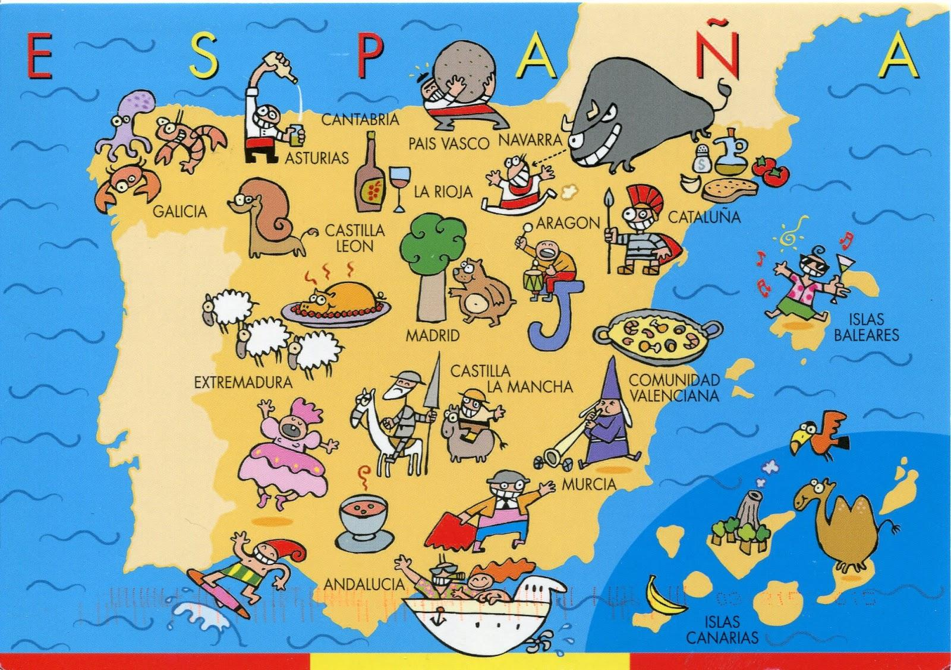](https://www.google.co.uk/url?sa=i&url=https%3A%2F%2Fmaps-spain.com%2Fmap-of-spain-for-kids&psig=AOvVaw3254oeloT1g0B6VCK8gnbo&ust=1587499914446000&source=images&cd=vfe&ved=0CAIQjRxqFwoTCMCk05no9-gCFQAAAAAdAAAAABAD)

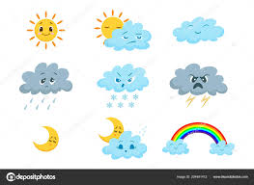



**Important Vocabulary**

El tiempo- the weather

Está nublado (It’s cloudy)

Llueve (It rains)

Hace frío (It’s cold)

Nieva (It snows)

Hay viento (It’s windy)

Hay niebla (It’s foggy)

Hace calor (It’s warm)

Está soleado or Hace sol (It’s sunny)

Hace buen tiempo (It’s fine weather)

El tiempo es horrible (It’s bad weather)