Our Lady and St Edwards Knowledge Organiser | Year 6 - Art | Autumn | Pop Art
Key Facts about the Artist |  | Key Vocabulary
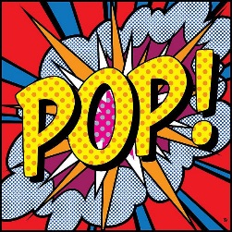  Name: Eduardo Paolozzi  Life: 7 March 1924 - 22 April 2005  Country of Birth: Edinburgh, Scotland  Period: Pop Art, Surrealism & Modern Art  Media: Paint –etching process (Photogravure), Bronze (Sculptures)  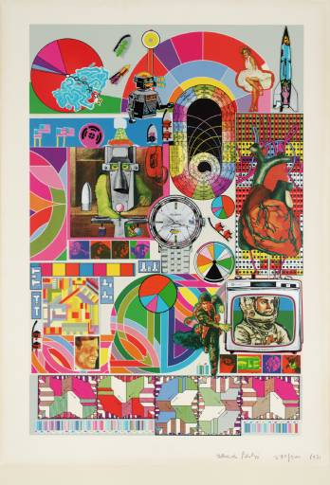  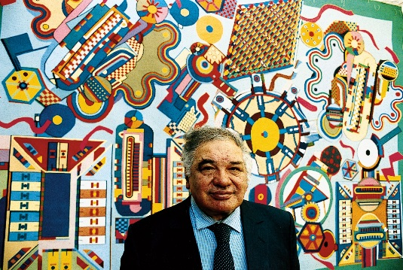 |  | - Canvas - a painting made on a piece of cloth stretched on a frame.  - Photogravure - an image produced from a photographic negative transferred to a metal plate and etched in.  - Pop Art - art based on modern popular culture and the mass media, especially on traditional fine art values.  - Modern Art - art of a style that has been created between the late 19th and the late 20th centuries.  - Sculptor - A sculptor shapes clay, stone, marble, wood, bronze etc. into two- or three-dimensional art. Some sculptors carve out stone or marble or weld pieces of metal together into freestanding statues. Sculptors also carve into walls or other surfaces, a technique called relief.  - Etching - a print produced by the process of etching.
Key Questions |  | Books, internet sites and places to visit
- Do you know about any other famous artists?  - What is Pop Art and who are the most famous artists?  - What materials are needed to complete the etching process?  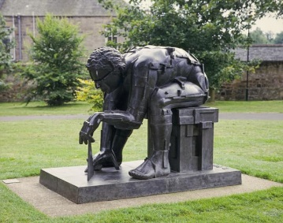  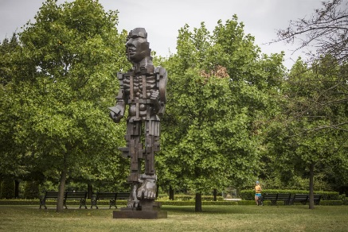  - Why is Pop Art classed as Modern Art? |  | https://www.tate.org.uk/art/artists/sir-eduardo-paolozzi-1738  https://www.royalacademy.org.uk/art-artists/name/eduardo-paolozzi-ra  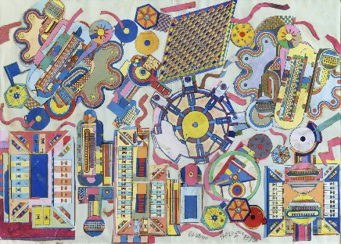  https://www.tate.org.uk/art/artworks/paolozzi-the-childrens-hour-p01994

