 | Context for learning  - Question | Activity
Day one  Learning Focus:  Features of a bar chart | In Focus:  ‘The table shows the number of cupcakes sold in a shop on a particular day. How can we represent this information in a graph?’  (MNP page 206)  Children to think about the various types of graphs they may have previously explored. E.g. bar charts, picture graphs, line graphs etc.  Focusing on bar charts- what do they already know?  Revisit all of the features of bar charts; e.g. the axis, labelling, titles and scale etc.  Explore some examples of bar charts together, highlighting the various features. (PP) | Group 1:  Children to explore the features of a bar chart. Children will recognise and be able to highlight these features on examples of bar charts.  Children to be able to use a table of information to complete a bar chart.
Group 2:
Children to explore the features of a simple bar chart. Children will recognise and be able to highlight these features on examples of simple bar charts.
Children to be able to use a table of information to complete a simple bar chart.

Day two  Learning Focus:  Interpreting bar charts | In Focus:  (CGP page 143)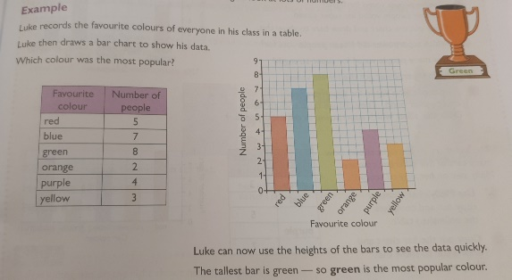  Discuss the bar chart. What can they see/ tell from looking at it? What data is the bar chart representing?  Recap how we read bar charts using the x and the y axis.  Prompt children to ask more questions relating to the bar chart. | Group 1:  Children to look at and interpret simple bar charts, where the bars are placed on the scale lines.  Children to be able to interpret data in bar charts where the bars read between the scale.  Children to be able to answer questions about the data using the bar chart as a basis.
Group 2:
Children to look at and interpret simple bar charts, where the bars are placed on the scale lines.
Children to be able to answer simple questions about the data using the bar chart as a basis.

Day three  Learning Focus:  Gathering and representing data in a bar chart | In Focus:  Use a table and a bar chart to show the spelling results of 4 pupils.  Amira- 7  Sam- 3  Emma- 5  Charles 9  Children to discuss how we would represent this information in a table.  Discuss how this information can be used to label the x and y axis.  Discuss with the children about gathering data- what kind of data might we collect? E.g. favourite colour, drink, food etc  Children will then gather data based on their favourite crisp flavour  Model how to present this data in a table and then a bar chart, reflecting on all the key features spoken about earlier on in the week. | Group 1:  Children will gather data based on their favourite crisp flavours.  Children will present this data in a table format before using this information to create a bar chart.  Can children begin to formulate questions around their data? For example, how many children chose salt and vinegar?
Group 2:
Children will gather data based on their favourite crisp flavours.
Children will present this data in a table format before using this information to create a bar chart.

Day four  Learning Focus:  Analysing and forming questions relating to their own bar charts | 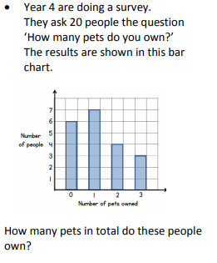  In Focus:  Discuss the bar chart in detail. What is it representing?  How would we work out the total number of pets? Use the scale- 6 people had 0 pets + 7 people had 1 pet + 4 people had 2 pets + 3 people had 3 pets. 7+8+9= 24 | Group 1:  Using the bar charts they have created, children to pose and answer questions relating to a partners bar chart.  Children will use the words more than and less than to formulate questions.  For example, ‘how many more children preferred salt and vinegar to prawn cocktail?’
Group 2:
Using the bar charts they have created, children to pose and answer simple questions relating to a partners bar chart.
For example, ‘how many children preferred salt and vinegar?’

Day five
INSET DAY
Evaluation/Reflection/Intervention (To be completed in PPA)

