 | Context for learning  - Question | Activity
Day one  Learning Focus:  Doubling | Using Dobby and the Doubling machine.  If Dobby puts three apples in the doubling machine, how many apples will he have? | Set 1:  Pupils to double up to 20.  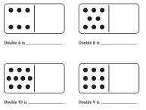
Set 2:
Pupils to double up to 15.
Set 3:
Pupils to double up to 10.
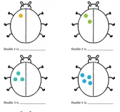
Day two  Learning Focus:  Recording doubling number sentences using addition | Show pupils examples of doubling:  How could we write this as a number sentence? | Set 1:  Pupils to record addition number sentences for doubles up to 20.
Set 2:
Pupils to record addition number sentences for doubles up to 15.
Set 3:
Pupils to record addition number sentences for doubles up to 10.
Day three  Learning Focus:  Halving numbers | Two friends buy 10 apples. How many do they get each? | Set 1:  Pupils to halve numbers up to 15.  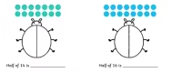
Set 2:
Pupils to halve numbers up to 15.

Set 3:
Pupils to halve numbers up to 10.

Day four  Learning Focus:  Understand that halving is the inverse of doubling | If double 5 is 10, and half of 10 is 5?  What does that mean? | Set 1:  Pupils to complete doubling and halving questions to 20.  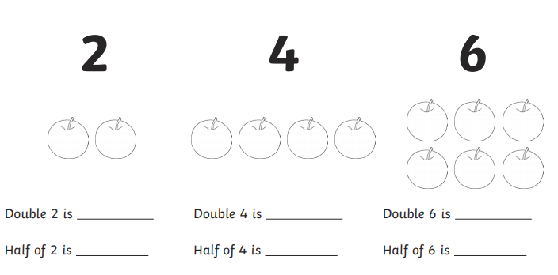
Set 2:
Pupils to complete doubling and halving questions to 15.

Set 3:
Pupils to complete doubling and halving questions to 10.

