Focus: tell and write the time to five minutes, including quarter past/to the hour and draw the hands on a clock face to show these times
 | Context for learning  - Question | Activity
Day one  Learning Focus:  Reading the time  O’clock, half past,  quarter past, quarter to | Question:  What time does this clock say?  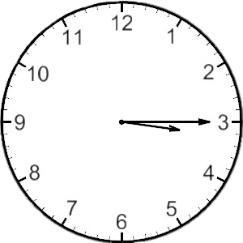  How do you know? Explain your answer. | Set 1 HA MA  Starter – Telling the time bingo  Activity – Matching the written word with the clock face  e.g o’clock  half past 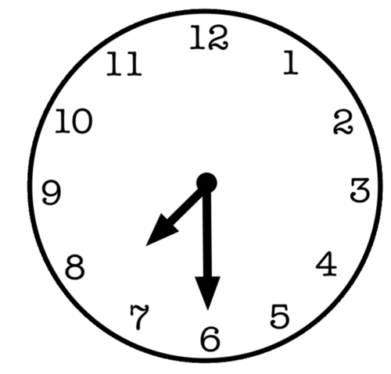  Children understand where the number is written  6 O’clock half past 9 quarter past 10 quarter to 12  Writing the time correctly underneath clock face in books (o clock, half past, quarter past, quarter to)  Extension – What’s the time? show me clock game
Set 2 LA

Starter – Using mini clocks to show half past and o’clock times

Activity – Cut and stick
Matching the written word with the clock face (oclock and half past)
Children understand where the number is written
6 O’clock half past 9

Writing the time correctly underneath clock face in books

Extension - Recap quarter past and quarter to

Day two  Learning Focus:  Answering written word problems  Reading the time in five minute intervals | Question:  Anna gets on the train at 1:30 (half past one) her journey takes one hour. What time will she arrive?  How do you know? Explain your answer | Set 1 HA MA  Starter – Answering challenge questions as a class – using large topmarks teaching clock to discuss answers  Activity – Introducing 5 minute intervals – counting in fives  Plenary –
Set 2 LA

Starter – Answering challenge questions as a class – using large topmarks teaching clock to discuss answers

Activity – Quarter past and quarter to
Cut and stick, reading clock face and matching with the correct written time

Plenary -
Day three  Learning Focus:  Telling the time in five minute intervals | Question:  Tom gets on the bus at 12:10 his journey is 20 minutes long. What time will he arrive? | Set 1 HA MA  Starter – Answering challenge questions as a class – five minute intervals – using large topmarks teaching clock to discuss answers and model counting in fives around the clock face  Activity – Practise counting in fives around the clock face – answering questions on worksheet  Extension – reading the time in five minute intervals e.g. twenty past 10, ten past 11
Set 2 LA

Starter – Answering challenge questions as a class – five minute intervals – using large topmarks teaching clock to discuss answers and model counting in fives around the clock face

Activity – Practise counting in fives around the clock face – answering questions on worksheet (between five past and half past)

Plenary - Extension – reading the time in five minute intervals e.g. twenty past ten
Evaluation/Reflection/Intervention (To be completed in PPA)

