**Did you know?**

The capital city of Spain is Madrid.

¿Cuántos años tienes? (How old are you?)

Tengo cinco/seis años. (I am 5/6 years old)

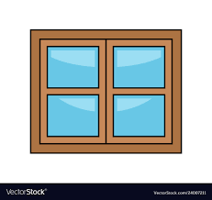



[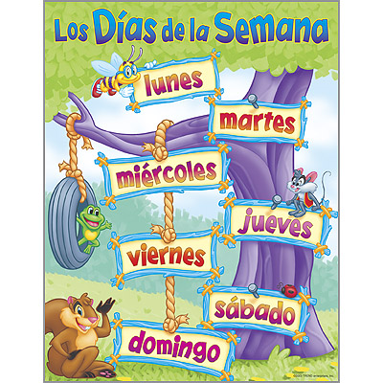](https://www.google.co.uk/url?sa=i&url=https%3A%2F%2Fwww.clipart.email%2Fclipart%2Fdays-of-the-week-in-spanish-clipart-61440.html&psig=AOvVaw06CKVw4JNNgWv-dVRZffx8&ust=1587573308129000&source=images&cd=vfe&ved=0CAIQjRxqFwoTCNDKls75-egCFQAAAAAdAAAAABAD)

lunes- Monday

martes- Tuesday

miércoles- Wednesday

jueves- Thursday

viernes- Friday

sábado- Saturday

domingo- Sunday



During the Spring Term, Year 1 children will revise parts of the body from F2 and will learn how to say their age. They will also be able to identify large classroom items and recognise their names in Spanish. Later on in the term, Year 1 children will learn the days of the week, listen to a story in Spanish and will recognise some smaller classroom items.

**Year 1 Knowledge Organiser Spring Term Spanish**

la computadora (the computer)

la pizarra (the board)

la mesa (the table)

la puerta (the door)

la ventana (the window)

la silla (the chair)

el armarío (the cupboard)

la luz (the light)

un estuche (a pencil case)

un bolígrafo (a biro)

un sacapuntas (a pencil sharpener)

un lápiz (a pencil)

una regla (a ruler)

una goma (a rubber)

una pluma (a fountain pen)

tijeras (scissors)