Our Lady and St Edwards Knowledge Organiser | Year 3 - Art | Spring | North African Art
Key People, Places and Dates |  | Key Vocabulary
- African art describes the modern and historical paintings, sculptures and other visual culture from native Africans and the African continent.  - Rock art is the earliest art form in Africa. The oldest images scientifically dated are in Namibia from about 24-27,000 years ago, but most experts agree that Africa's rock art may date to more than 50,000 years ago.  - The earliest known sculptures are the terracotta pottery heads, most of them fragments of figures, from the Nok culture of Nigeria and are dated around 500 BCE through to 200 ADE.  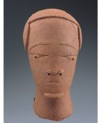  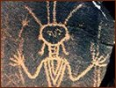  - In the 19th and 20th Century many sculptors and artists create North African Masks using other forms are North African Prehistoric sculptures as inspiration. |  | - Terracotta - a type of fired clay, typically of a brownish-red colour and unglazed, used as an ornamental building material and in modelling.  - BCE - Before the Common Era  - AD - Anno Domini, a Latin phrase meaning “in the year of our Lord.  - Native - a person born in a specified place or associated with a place by birth.  - Sculpture - the art of making two- or three-dimensional representative or abstract forms, especially by carving stone or wood or by casting metal or plaster.  - Modroc - is plaster bandage that is used for modelling, casting and crafting.  - Mask - in art history, especially sculpture, "mask" is the term for a face without a body.
Key Questions |  | Books, internet sites and places to visit
How old is North African Art?  How was art in North Africa first recorded?  Why would we use Modroc for a sculpture?  Why is a wire frame used before sculpting?  What colours did the Northern African’s use to decorate masks?  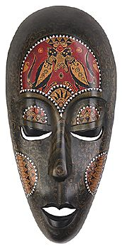  Why did they use those colours?  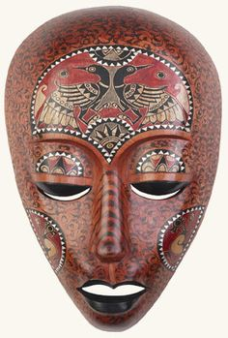 |  | https://www.twinkl.co.uk/search?term=african+art  https://art-educ4kids.weebly.com/african-art.html  https://www.artyfactory.com/africanmasks/  https://www.planmyschooltrip.co.uk/1150/African-Masks.php  https://www.ducksters.com/history/africa/ancient_african_art.php  