Our Lady and St Edwards Knowledge Organiser | Year 4 - Art | Spring | Art That Tells a Story
Key Facts about the Artist |  | Key Vocabulary
Name: Jackie Gale  Country of Birth: Midlands, England  Period: Contemporary Art  Media: Textiles/Fabric  A self-taught artist, Jackie blends her passion for art with textile creativity to tell a story of a place or theme. Narrative is an essential component of her work and she tells the story with texture, colour and a unique style of illustration using free motion embroidery. |  | Printing – an impression made by any method involving transfer from one surface to another.  Textiles – are woven or knitted cloth. Lace, felt, and many other kinds of cloth are considered textiles, too.  Fabric - is cloth or other material produced by weaving together cotton, nylon, wool, silk, or other threads.  Narrative – A narrative is a story that you tell to someone, usually in great detail.  Embroidery - needlework done to decorate cloth  Component - one of the parts or units of a combination,  Romanesque Period - Romanesque art is the art of Europe from approximately 1000 AD to the 12th century.  Tapestry - is a form of textile art, traditionally woven by hand on a loom.
Key Questions |  | Books, internet sites and places to visit
- What is a tapestry?  - Why do some artists use fabrics to create art?  - What story can you see in the artwork from Jackie Gale?  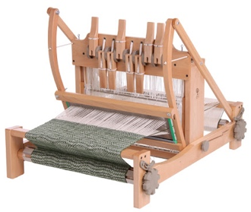  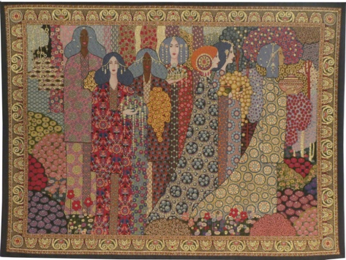  - During the Romanesque Period what tool did they use to create a tapestry? |  | https://www.jackiegaletextileart.com/  https://www.bbc.co.uk/bitesize/topics/zsmxsbk  https://twotempleplace.org/wp-content/uploads/2017/12/Art-Design-Unit-5C-Talking-Textiles-WM.pdf  https://www.tes.com/teaching-resource/textiles-as-a-technique-6096550  