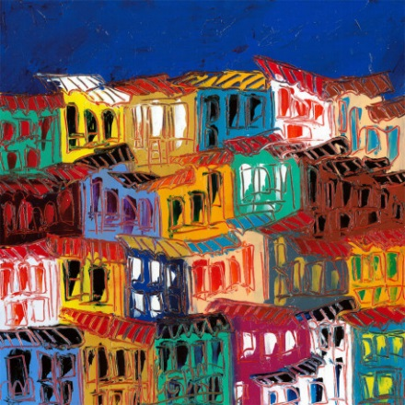
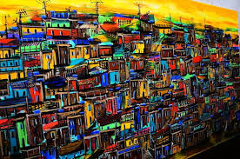
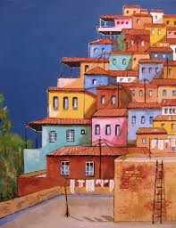
Key Information UNICEF have commissioned many cultural and ethical artists’ to produce compositions that highlight the living conditions of some of the world’s most deprived areas.

Domingos Cardosa da Silva
Domingos was born in Muranhao in the North East of Brazil. His art was influenced by his father and his love of colour and painting grew throughout his childhood. When he was old enough he moved to Rio. He was fascinated by the bright lights and excitement of the Capital City but he was drawn to the busy landscapes of the Favela districts. His most famous work depicts the vibrant life of Rio’s Favela Districts.

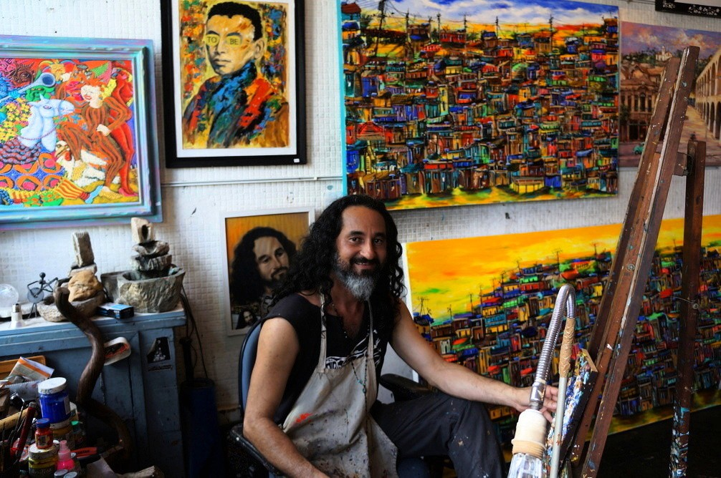
Art Knowledge Organiser
Year 6 Spring Term – South American Art

Key Vocabulary
Contemporary Art | The art of today. Art period beginning in the late 20th Century
Complimentary Colours | Colours close to each other on the spectrum
Contrasting Colours | Opposing colours on the spectrum
Primary Colours | Red, Blue and Yellow
Secondary Colours | Purple, Green and Orange
Medium/Media | Materials used such as oil pastel and ink
Perspective | The impression of depth and space
Scale | Increasing or decreasing proportion
Tonal Line | Use of line to create detail, perspective or depth

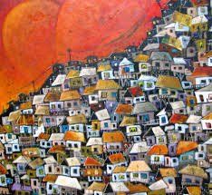
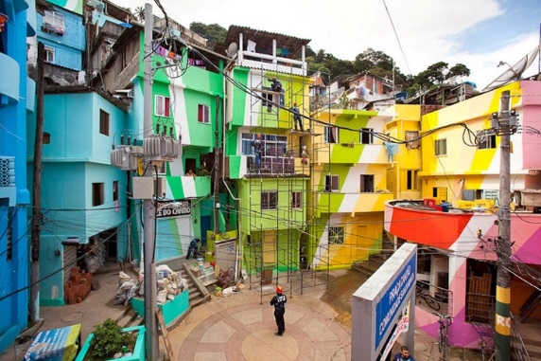
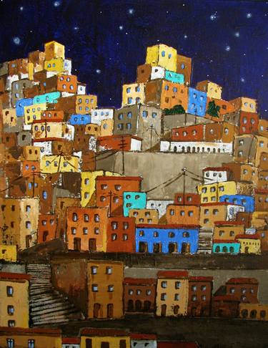
By the end of this unit
Create sketch books to explore and record their own creative responses
Improve their mastery of art techniques using a range of mediums

