We hope that this information will support parents, carers and pupils in accessing and understanding our remote education provision during the Covid-19 Pandemic, including local and national restrictions require entire cohorts or bubbles to remain at home.
For details of what to expect where individual pupils are self-isolating, please see the final section of this page.

What should my child expect from immediate remote education in the first day or two of pupils being sent home?

We have been supporting home learning since the beginning of the first lockdown in March 2020. From September 2020 we have developed comprehensive remote learning to support those pupils working from home both in school and at home. This means that we can provide access immediately to those needing self-isolation or during a full national lockdown. Children will have activities set for them on Tapestry (F1 & F2) and on School Spider (F2-Y6). On the school website there are tutorials on how to access the School Spider, aiding instant access to remote learning.

Following the first few days of remote education, will my child be taught broadly the same curriculum as they would if they were in school?
We are doing our best to provide the same high quality curriculum for all of our pupils both in school and at home. We have made some adaptations in subjects for those pupils working remotely. For example, we have identified topics and lessons within the Oak National Academy and the BBC Bitesize which closely match those within the curriculum, ensuring that your child has the resources and support to aid their learning.
How long can I expect work set by the school to take my child each day?
We suggest that remote education (including remote teaching and independent work) will take pupils broadly the following number of hours each day:
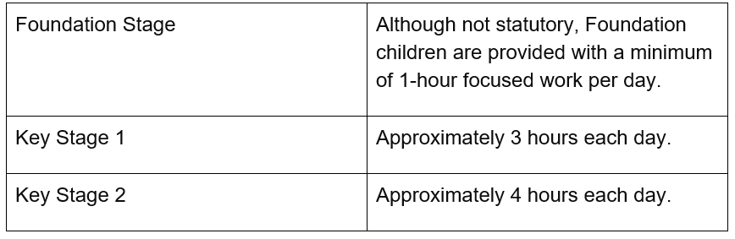

Accessing remote education

How will my child access any online remote education you are providing?
At Our Lady’s & St. Edward’s, we use School Spider for remote education. This enables each child to access daily work, activities and tasks uploaded by their class teacher. When the work is completed, it needs to be uploaded to enable teacher feedback.
Pupils in Foundation Stage (F1/ Pre-School and F2/ Reception) are provided with daily activities through Tapestry. Pupils receive feedback from their teacher and Key Worker which is used to track progress and evidence attainment within the EYFS areas of learning.
We also provide links to numerous online education sites and a wide range of resources on our school website to support children’s learning. This is in addition to the work posted to School Spider/Tapestry.

If my child does not have digital or online access at home, how will you support them to access remote education?
- Laptops and tablets are available to loan from school during isolation/lockdown. These will be provided on a priority basis in line with government guidance. Please contact the School Office if you require a device.
- Routers and mobile data extensions are available if you do not have internet access, or limited data. You should have received an email with this information. Please contact the School Office if you require a router or mobile data.
- Paper-based Home Learning packs are available every Monday; these packs contain printed work from the previous week’s online learning.
- Once completed, please return the complete Home Learning pack on the following Monday as the work needs to be marked. It is important that your child receives feedback to support their progress and maximise attainment.

How will my child be taught remotely?
We use a combination of the following approaches to teach pupils remotely:
- daily lessons uploaded to the School Spider
- The school reading scheme can be accessed online as we have purchased the license to enable pupils to select and read graded reading books.
- We have daily and weekly activities including cookery, authors and links to a range of external resources and providers.
- recorded teaching (e.g. Oak National Academy lessons, video/audio recordings made by teachers)
- printed paper packs produced by teachers (e.g. workbooks, worksheets)
- textbooks and a range of books from school
- commercially available websites supporting the teaching of specific subjects or areas, including video clips or sequences

Engagement and feedback
What are your expectations for my child’s engagement and the support that we as parents and carers should provide at home?
- We expect all children to engage in remote education as much as possible and practical.
- As a parent/carer we are here to support you in providing clear and structured routines to support your child’s home learning. We understand that at times this might be difficult with the many demands of family life and work commitments. Please contact school if you need support as we know that all parents want to do their best.

How will you check whether my child is engaging with their work and how will I be informed if there are concerns?
- We will be tracking engagement, providing feedback and marking work submitted via School Spider and in home learning packs. If we are concerned about your child’s engagement, we will contact you by phone to offer support.

How will you assess my child’s work and progress?
Feedback can take many forms and may not always mean extensive written comments for individual children. For example, whole-class feedback or quizzes marked automatically via digital platforms are also valid and effective methods, amongst many others.
Our approach to feeding back on pupil work is as follows:
- Children who are submitting work online will receive a written comment through the School Spider, they may also be given feedback online by receiving a mark out of 10.
- Children using printed home learning packs will have their work marked weekly.

Additional support for pupils with particular needs
How will you work with me to help my child who needs additional support from adults at home to access remote education?
We recognise that some pupils, for example some pupils with special educational needs and disabilities (SEND), may not be able to access remote education without support from adults at home. We acknowledge the difficulties this may place on families, and we will work with parents and carers to support those pupils in the following ways:
- Additional learning packs will be provided for those with specific learning needs. Specialised resources will be available on the website aimed at those with additional or specific needs.
- The SENCO will ensure that all SEND children have access to the equipment they would receive in school (e.g. pencil grips, vocabulary charts, writing slopes etc.)
- Some children will be invited into school to ensure that their needs are met, where there is adequate space/support.

Remote education for self-isolating pupils

Where individual pupils need to self-isolate but the majority of their peer group remains in school, how remote education is provided will likely differ from the approach for whole groups. This is due to the challenges of teaching pupils both at home and in school.
If my child is not in school because they are self-isolating, how will their remote education differ from the approaches described above?
- The work set for isolated children will not differ greatly from the work in class, it will be taught as part of a planned and well-sequenced curriculum with meaningful and ambitious work set each day in a number of different subjects, including providing feedback.

As always it is important that we all work together to support our pupils and families at this difficult time. We are here to help and we urge parents and carers to contact school if they need any support, advice or resources to enable their child to participate fully in remote learning.
Thank you, stay safe and above all stay well.

