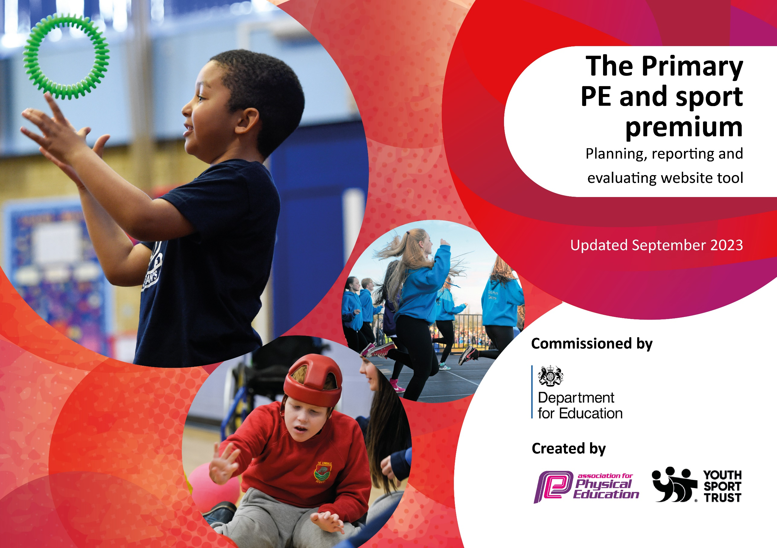

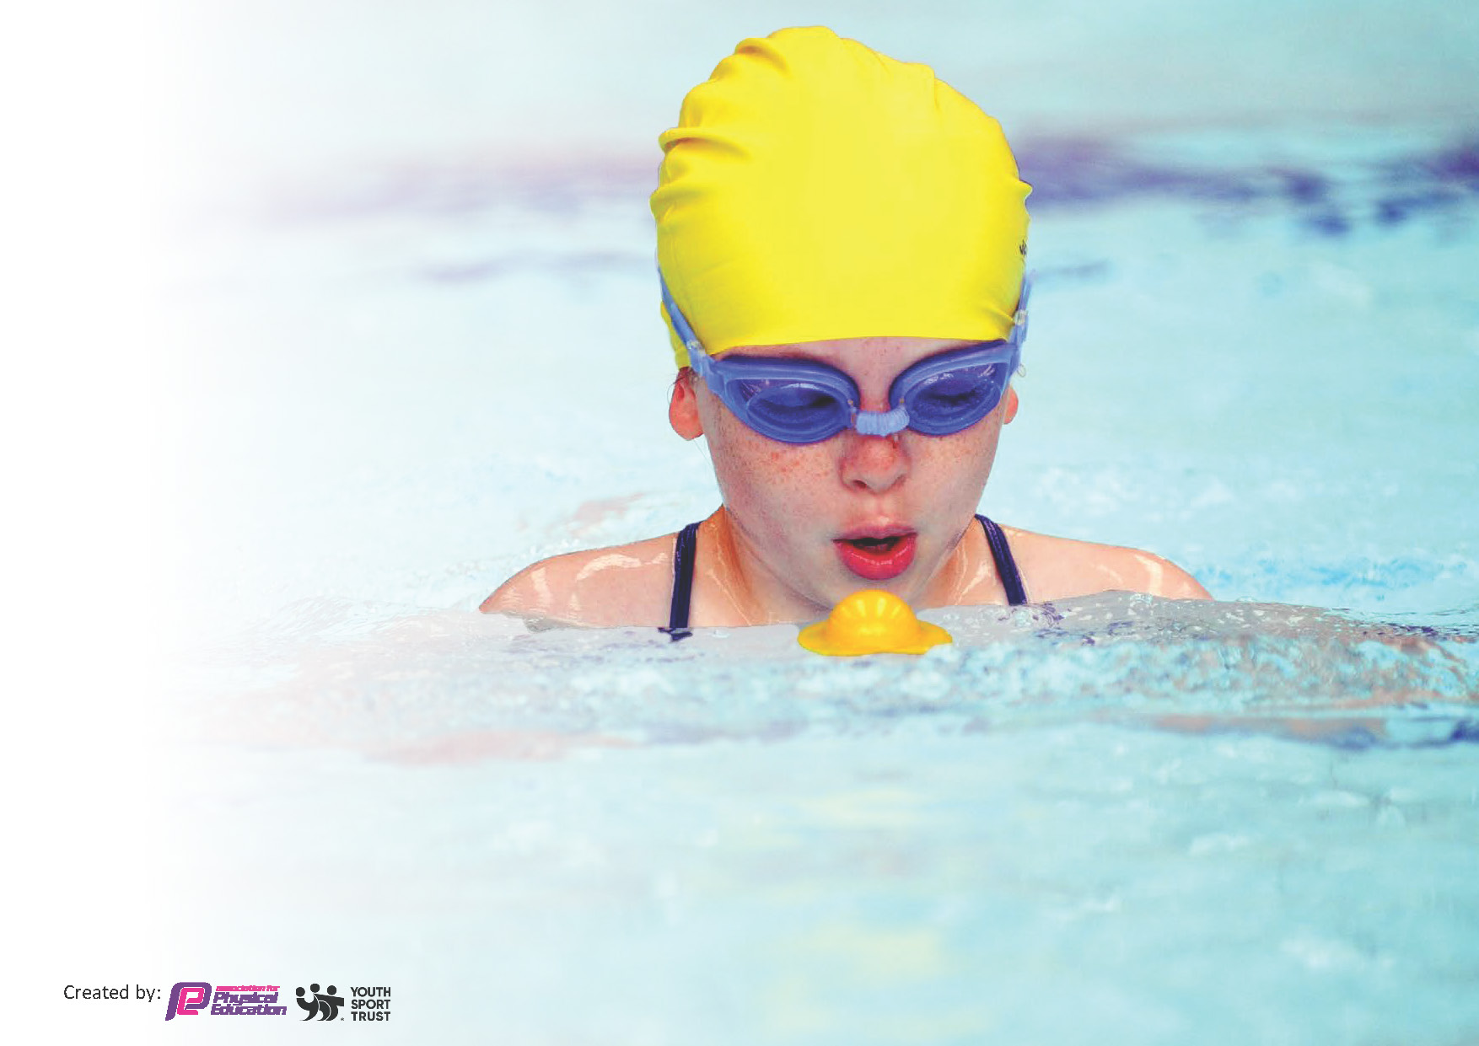
This template can be used for multiple purposes:
by:
- It enables schools to effectively plan their use of the Primary PE and sport premium
- It helps schools to meet the requirements (as set out in guidance) to publish information on their Primary PE and sport premium
- It will be an effective document to support Ofsted inspections enabling schools to evidence progress in Physical Education (PE) and evidence swimming attainment, which forms part of the PE National Curriculum. We would recommend schools consider
the Intent, Implementation and Impact of any spend, as examined within the Education Inspection Framework.

It is important that your grant is used effectively and based on school need.

Schools must use the funding to make additional and sustainable
improvements to the quality of the PE, School Sport and Physical Activity (PESSPA)
they offer. This means that you should use the Primary PE and sport premium to:

- Build capacity and capability within the school to ensure that improvements made now will benefit pupils joining the school in future years
- Develop or add to the PESSPA activities that your school already offers.

The Primary PE and sport premium should not be used to fund capital spend projects; the school’s core budget should fund these. Further detail on capital expenditure can be found in the updated Primary PE and sport premium guidance.

The Primary PE and sport premium guidance, outlines 5 key priorities that funding should be used towards. It is not

necessary that spending has to meet all the key priorities, you should select the priorities that you aim to use any funding towards.

Although completing this template is not a requirement for schools, schools are required to publish details of how they spend this funding. Schools must also outline what the impact this funding has had on pupils’ PE and sport participation and attainment and how any spending will be sustainable in the future. All funding must be spent by 31st July 2024.

The Department for Education has worked closely with the Association for Physical Education (afPE) and the Youth Sport Trust (YST) to develop this template and encourages schools to use it. This template is an effective way of meeting the reporting requirements of the Primary PE and sport premium.
Review of last year’s spend and key achievements (2022/2023)

We recommend you start by reflecting on the impact of current provision and reviewing your previous spend.

Activity/Action | Impact | Comments
- Introduce opportunities for children to experience new activities to encourage more pupils to take up sport.  Extra curricular clubs offered to all children to support children enjoying a number of sports throughout the school year.  - Residential Financial support for PP and Free School Meals children. | - 100% of children who attended after school clubs met the 'Active 60 minutes'.  90% of children who attended after school clubs participated in competitions.  100% of children increased social skills.  - 95% of pupils felt more confident to try new things they would not have done before the residential.  85% of pupils said their residential experience helped them realise they could get on with people from the other class. | - Continue to develop a wide range of extra-curricular activities.  - Continue to financially support PP and FSM children.

Key priorities and Planning
This planning template will allow schools to accurately plan their spending.

Action – what are you planning to do | Who does this action impact? | Key indicator to meet | Impacts and how sustainability will be achieved? | Cost linked to the action
Increased knowledge and confidence of all staff, leading to high-quality curriculum PE lessons.  - Purchase of Edsential Curriculum Support (6 week programme)  1 x Autumn Confirmed  - Edsential Subject Leader Support Programme  - Purchase of Scheme of work  - Purchase of PE TA | Teachers.  Pupils. | Key Indicator 1: Increased confidence, knowledge, and skills of all staff in teaching PE and sport.  Key indicator 3: Raising the profile of PE and sport across the school, to support whole school improvement.  Key indicator 5: Increased participation in competitive sport. | Proposed Impact:  - Primary teachers will be more competent and confident to deliver effective curriculum PE lessons having taken part in 6 x ½ days of PE CPD each (staff audits).  - Lesson observations show pupils receive Quality First Teaching across the whole PE curriculum - supported through our Total PE+ subscription, including making links to wider curriculum and supporting social development.  - Curriculum PE assessments will show an increased number of children working at age-related expectations for PE.  Evidence:  Staff Voice: All school staff are using Total PE+ for individual lesson plans to support teaching and learning.  100% of staff reported an increase in confidence teaching PE following the Curriculum Support Programmes.  Pupil Voice:  86% of children reported they enjoy PE lessons.  Curriculum PE Assessments show:  - 78% of children working at ARE (whole school)  - 78% of children working at ARE (Key Stage 1)  - 79% of children working at ARE (Key Stage 2) | - Edsential Curriculum Support - £1025  - Edsential Subject Leader Programme - £960  - SoW - £420  - PE TA - £1962.63
To increase safe participation in PE lessons.  Purchase of PE Kit for children without.  Sports Safe Inspection | Pupils | Key indicator 2 -The engagement of all pupils in regular physical activity | More pupils will be meeting their daily physical activity goal (30 minutes within school hours) compared to 2022/23.  More pupils will be engaged in Physical Education to support their learning and development.  Curriculum PE Assessments show:  - 78% of children working at ARE (whole school)  - 78% of children working at ARE (Key Stage 1)  79% of children working at ARE (Key Stage 2) | - PE Kit - £846.50  - Sports Safe - £90
To increase physical activity levels to ensure children are meeting the active 30 minutes within school.  - Extra-curricular clubs  - Daily Mile markings  - Purchase of lunchtime activity equipment | Pupils.  Support Staff/ Lunchtime staff. | Key indicator 2 -The engagement of all pupils in regular physical activity – the Chief Medical Officer guidelines recommend that all children and young people aged 5 to 18 engage in at least 60 minutes of physical activity per day, of which 30 minutes should be in school.  Key indicator 3: Raising the profile of PE and sport across the school, to support whole school improvement.  Key Indicator 4: Offer a broader and more equal experience of a range of sports and physical activities to all pupils. | Proposed Impact:  More pupils will be meeting their daily physical activity goal (30 minutes within school hours) compared to 2022/23.  More pupils taking part in PE and Sport Activities outside of school hours compared to 2022/23.  Increased number of children participating in breakfast and afterschool clubs.  Evidence:  Extra-Curricular Clubs:  - Total number of children who attended at least one extra-curricular club in 23/24 = 290  - 64% of KS2  - 45% of KS1  - 35% of EYFS  Compared to 22/23:  - Total number of children = 206  - 58% of KS2  - 33% of KS1  - 10% of EYFS | - Daily Mile – Tesco Vouchers  - ASC - £360 x 2  - Lunchtime activity equipment - £3,810.44
To support the development of physical literacy within children.  - Edsential Fundamentals Programme  Spring 1 (Year 1)  Spring 2 (Year 2)  - PE equipment for use in after and before school clubs  - Qualified Support Staff to attend swimming lessons | Pupils.  Pupils and Staff | Key indicator 2 -The engagement of all pupils in regular physical activity – the Chief Medical Officer guidelines recommend that all children and young people aged 5 to 18 engage in at least 60 minutes of physical activity per day, of which 30 minutes should be in school.  Key Indicator 4: Offer a broader and more equal experience of a range of sports and physical activities to all pupils  Key indicator 5: Increased participation in competitive sport. | Proposed Impact:  Fundamentals Programme will allow more children to participate in extra-curricular clubs to develop physical skills and social and emotional skills.  Curriculum PE assessments will show increased ‘physical competence’ across the year.  Clubs will be offered every half term and go towards supporting physical development alongside increasing the number of children meeting the recommendation of 60 minutes physical activity per day.  Evidence:  Fundamentals Programme Impact Report:  https://sway.cloud.microsoft/KgGahR3uyHKIbaGU?ref=email  https://sway.cloud.microsoft/am3QtHWwNhHy48EG?ref=email  Curriculum PE Assessments show:  Curriculum PE Assessments show:  - 78% of children working at ARE (whole school)  - 78% of children working at ARE (Key Stage 1)  - 79% of children working at ARE (Key Stage 2)  Progression in Swimming  Current Y5 NC Pass Rate  2022-2023 – 5%  2023-2024 – 5%  Current Y6 NC Pass Rate  2022-2023 – 16%  2023-2024 – 32% | - Fundamentals Programme - £2460  - PE Equipment – Bishop Sports Voucher (Fundraised)  - PE Equipment - £2249.39  - Swimming Support Staff - £1489.60
To use school sport to develop social skills and promote physical activity outside of school.  Competitive Sports Equipment purchased (Football kit and shin pads) | Pupils. | Key indicator 5: Increased participation in competitive sport. | Proposed Impact:  Participation within competitive sport will support children to further develop teamwork skills, social and communication skills and supported wellbeing through a sense of ‘togetherness’.  Increased number of children participating regularly within a sports club/ team as a result of our competitions provision across the year.  Evidence:  Competitions and Events:  Number of sporting events attended:  - 2023 – 24 - 8  - 2022 – 23 - 9  - 2021-22 - 3 | - Competitive Sports Equipment - £101.28
Ensure participation in extra-curricular activities, including residential trips.  Lunch Club provided to enhance extra-curricular opportunities – Extra Lunch Club Staff Purchased | Pupils | Key Indicator 2: Engagement of all pupils in regular physical activity  Key Indicator 3: The profile of PE and sport is raised across the school as a tool for whole school improvement  Key Indicator 4: Broader experience of a range of sports and activities offered to all pupils | - 90% of pupils felt more confident to try new things they would not have done before the residential.  - 85% of pupils said their residential experience helped them realise they could get on with people from the other class. | - Residential Trip - £1350  - Lunch club staff - £1863
(Sports Day)  Enhance mental and physical development, social skills and even improvements in academic performance.  Children to learn how to cope in a competitive environment. | Pupils | Key Indicator 2: Engagement of all pupils in regular physical activity  Key Indicator 3: The profile of PE and sport is raised across the school as a tool for whole school improvement  Key Indicator 4: Broader experience of a range of sports and activities offered to all pupils  Key Indicator 5: Increased participation in competitive sport | Staff Voice:  - 100% of staff reported an increase in confidence supporting children on sports day.  Pupil Voice:  - 80% of children reported they enjoy sports day.  Compared to 2022/23:  - 94% of children reported they enjoy sports day.  - All children across the school participated in sports day. | - Sports Day Equipment - £350

Key achievements 2023-2024
This template will be completed at the end of the academic year and will showcase the key achievements schools have made with their Primary PE and sport premium spending.

Activity/Action | Impact | Comments
- Use of experienced and qualified Tas to attend swimming  - Purchase of scheme of work  - Purchase of midday lunch time assistants  - Purchase of Extra-curricular clubs  - Development of Sports Day Activities and purchase of new equipment | - Smaller swimming groups = more contact time in the pool. The Y5 to Y6 data doubled since last year (Swimming).  - Ensured continuity across the curriculum and clear areas of improvement throughout the children’s school journey (Ki1).  - Ensured more contact time with the children to support raising the profile of PESSPA across school (Ki2 and Ki3)  - More engagement across a wider range of sports to offer a broader range of experiences (Ki4)  - 25% increase in enjoyment of participation in competitive sporting events since previous year (Ki5) | - Next steps – train more members of staff to Level 1 swimming coach including class teachers.  - Next Steps – Continue to purchase scheme of work to ensure continuity and consistency across teaching.  - Next Steps - Development of specific lunch time activities to engage and entice more children to participate.  - Next Steps – Continue to develop sports day to include a wider range of activities – improve engagement.

Swimming Data
Meeting National Curriculum requirements for swimming and water safety.
Priority should always be given to ensuring that pupils can perform safe self-rescue even if they do not fully meet the first two requirements of the National Curriculum programme of study

Question | Stats: | Further context  Relative to local challenges
What percentage of your current Year 6 cohort can swim competently, confidently and proficiently over a distance of at least 25 metres? | 32%
What percentage of your current Year 6 cohort can use a range of strokes effectively [for example, front crawl, backstroke, and breaststroke]? | 37%

What percentage of your current Year 6 cohort are able to perform safe self-rescue in different water-based situations? | 41%
If your schools swimming data is below national expectation, you can choose to use the Primary PE and sport premium to provide additional top-up sessions for those pupils that did not meet National Curriculum  requirements after the completion of core lessons. Have you done this? | Yes/No
Have you provided CPD to improve the knowledge and confidence of staff to be able to teach swimming and water safety? | Yes/No

Signed off by:

Head Teacher: | Elaine McGunigall
Subject Leader or the individual responsible for the Primary PE and sport premium: | Catherine Hanton-Wise  PE Lead
Governor:
Date: | 05/07/2024

