Hello Year 3!

We hope you have had a good week and are looking forward to spending the Easter weekend with your family. This week we have got some Easter themed activities to keep you busy during your home learning time!
- Think about the people who live in your street- is there anyone who is elderly or lives on their own? Make them an Easter card and post it through their door to brighten their day!
- Use items from the garden or outdoor space to create an Easter garden, using the ideas below as inspiration- we would love to see photos of what you have made!
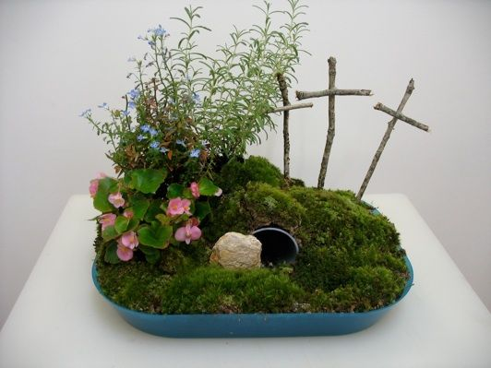
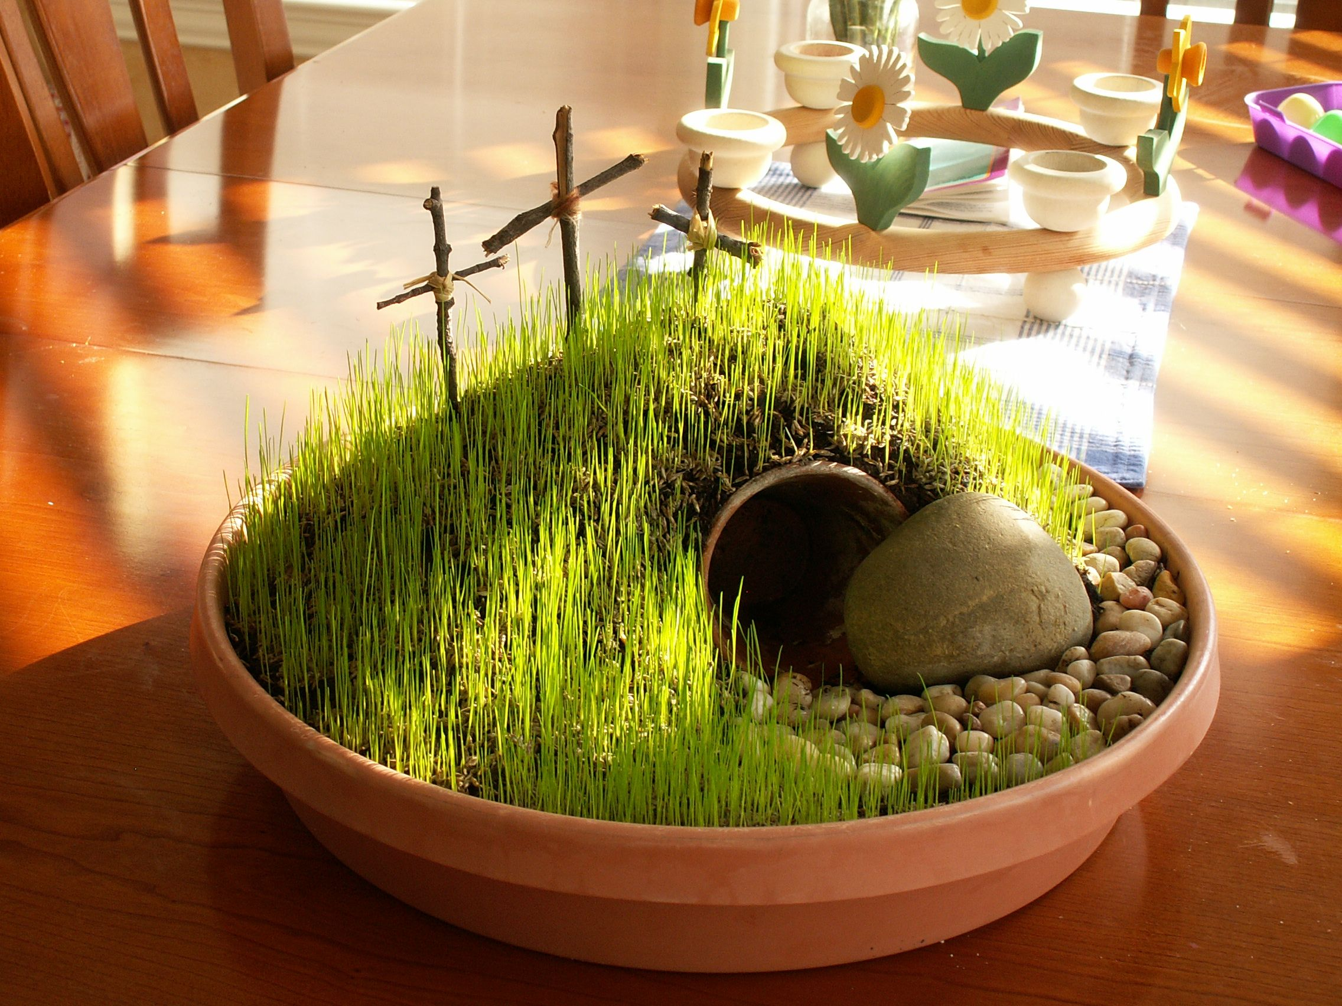
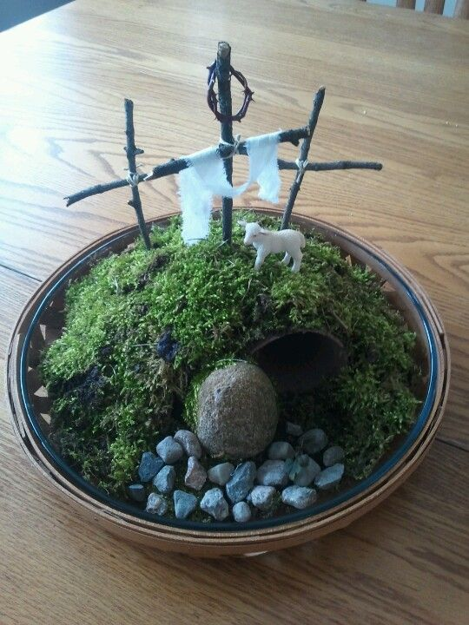

- Create a storyboard/comic strip telling the Easter story.
- Make a freeze-frame from the Easter story using lego or any of your favourite figures- can you write speech/thought bubbles for each character?
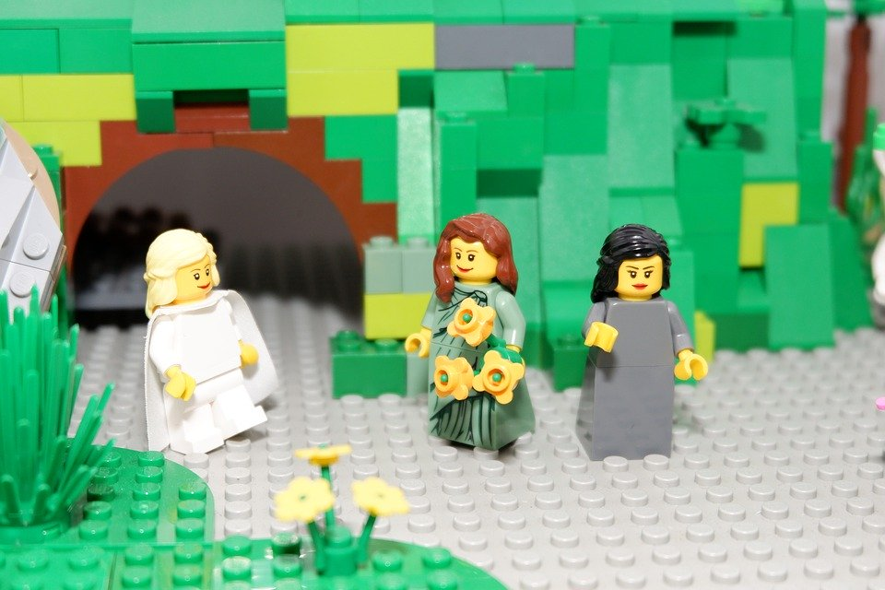
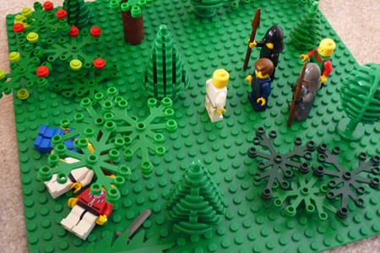
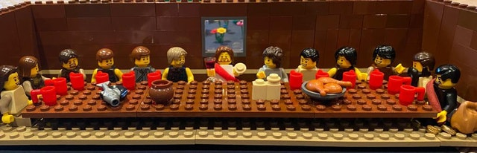

- Ask an adult to help you hard boil some eggs to decorate with paints and pens.
- Use your weaving skills from our art lessons to create a spring nest for the garden.
- Weigh the Easter eggs in your house and order them by weight.
- This week we would like you to all practise your 4 times table daily. Use the songs and activities on the BBC website to help you with this.
https://www.bbc.co.uk/teach/supermovers/ks1-maths-the-4-times-table-with-cyril-the-swan/zmsw382

This is a very different Easter weekend than what we are used to…but we hope that you enjoy spending time with your family and sharing in the joy of Easter Sunday together.

Take care, Mr Woodland and Mrs McAlynn

