2 X 5 = |  | 3 x 5 = |  | 4 x 10
3 X 2 = |  | 5 x 7 = |  | 10 x 3 =
1 x 2 = |  | 8 x 5 = |  | 7 x 10 =
2 x 4 = |  | 5 x 10 = |  | 10 x 9 =
8 x 2 = |  | 0 x 5 = |  |   2 x 10 =
11 x 2 = |  | 7 x 5 = |  | 10 x 10 =
2 x 9 = |  | 5 x 9 = |  | 6 x 10 =
0 x 2 = |  | 12 x 5 = |  | 10 x 5 =
10 x 2 = |  | 5 x 6 = |  | 12 x 10 =
2 x 6 = |  | 11 x 5 = |  | 10 x 8 =
7 x 2 = |  | 4 x 5 = |  | 1 x 10 =
2 x 2 = |  | 5 x 5 = |  | 10 x 0 =  So you have trained hard to master your 2, 5 and 10 times table, only the mighty Batman stands between you and glory! Good Luck!
0 x 2 = |  | 12 x 5 = |  | 10 x 5 =
10 x 2 = |  | 5 x 6 = |  | 12 x 10 =
1 x 2 = |  | 8 x 5 = |  | 7 x 10 =
8 x 2 = |  | 0 x 5 = |  | 2 x 10 =
2 x 4 = |  | 5 x 10 = |  | 10 x 9 =
2 ÷ 2 = |  | 10 ÷ 5 = |  | 100÷10 =
18 ÷ 2 = |  | 5 ÷ 5 = |  | 90 ÷ 10 =
6 ÷ 2 = |  | 45 ÷ 5 = |  | 60 ÷ 10 =

Batman is stunned that you got this far! He tries to use some word problems…
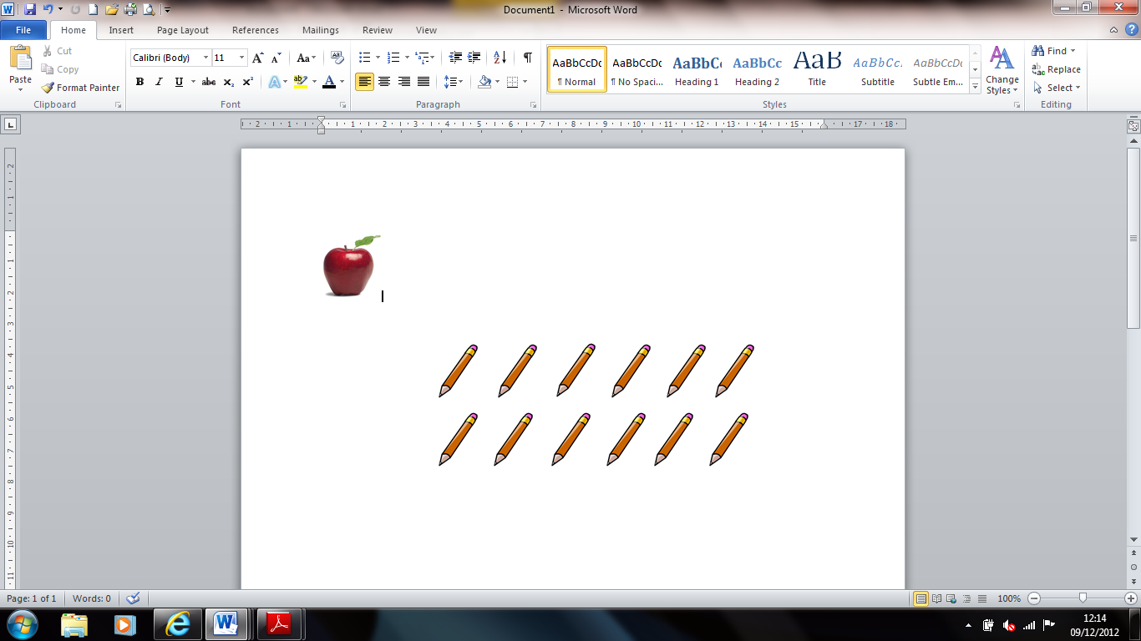
- There are 2 pencils in each pack. Emily bought 3 packets. How many pencils does she buy? _____ pencils
- I shared 30 buttons between 5 coats. How many buttons are there on each coat? _____ buttons 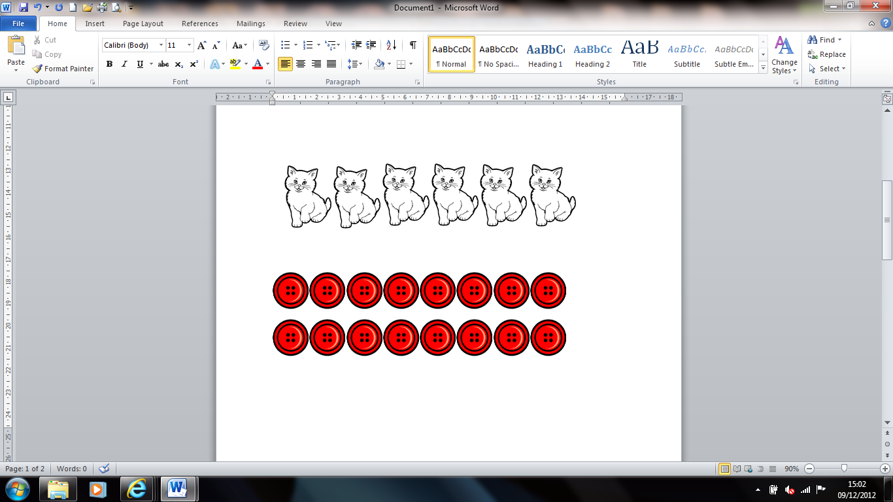

- There are 4 wheels on a car. How many wheels are there on 5 cars?
_______ wheels

- Liam shares 15 cakes between his 5 friends. How many cakes do his friends get each? _______ cakes 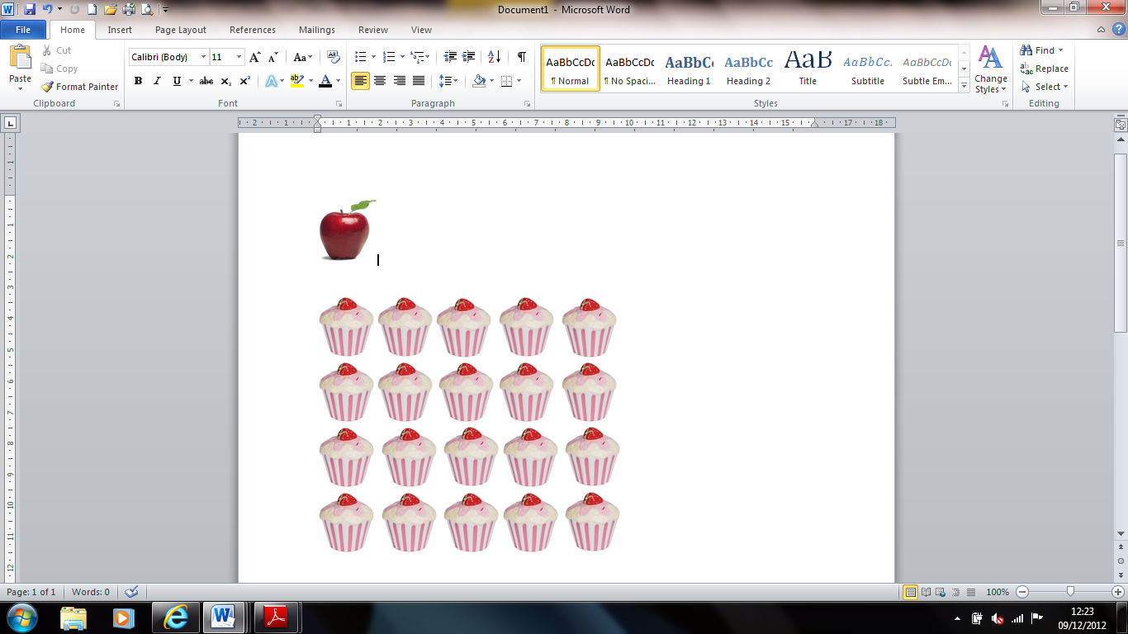

- There are 6 carrots in a box. Mason has 2 boxes. How many carrots does he have altogether? ________ carrotss

Your time
Time needed to beat Batman | 3 minutes 50 seconds

