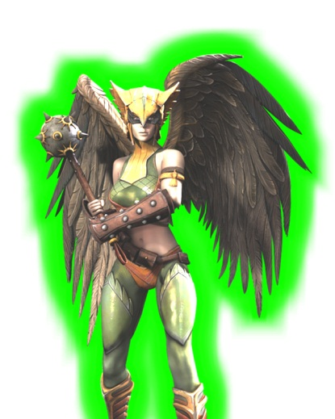
You have already beaten Batman, have you trained hard enough on your 3 and 4 times tables to beat the heroic Hawk-girl? Good luck!
3 x 3 = |  | 4 x 5 = |  | 10 x 10 =
2 x 5 = |  | 6 x 4 = |  | 8 x 4 =
4 x 3 = |  | 3 x 6 = |  | 9 x 4 =
2 x 11 = |  | 4 x 9 = |  | 3 x 10 =
3 x 9 = |  | 0 x 3 = |  | 0 x 4 =
2 x 8 = |  | 5 x 8 = |  | 12 x 5 =
6 x 3 = |  | 4 x 10 = |  | 10 x 1 =
12 x 2 = |  | 1 x 4 = |  | 3 x 11 =
1 x 3 = |  | 7 x 3 = |  | 5 x 9 =
7 x 2 = |  | 11 x 4 = |  | 4 x 6 =
10 x 3 = |  | 3 x 3 = |  | 5 x 5 =
2 x 2 = |  | 12 x 4 = |  | 3 x 12 =
2 x 11 = |  | 4 x 9 = |  | 3 x 10 =
36 ÷ 3 = |  | 15 ÷ 3 = |  | 36 ÷ 4 =
9 ÷ 3 = |  | 45 ÷ 5 = |  | 24 ÷ 3 =
18 ÷ 3 = |  | 16 ÷ 4 = |  | 50 ÷ 10 =
16 ÷ 2 = |  | 100 ÷ 10 = |  | 33 ÷ 3 =
11 x 4 = |  | 9 x 4 = |  | 4 x 6 =
10 x 3 = |  | 3 x 8 = |  | 5 x 9 =
2 x 11 = |  | 12 x 4 = |  | 3 x 12 =

Hawk-girl is knocked out of the sky by your amazing speed! She tries to use some word problems…
- Lola gives out 12 party bags at the end of her party. Inside each party bag there are 2 balloons. How many balloons does Sally give out? _______ balloons
- Four children can sit at a table. How many tables are needed to seat 48 children?
________ tables
- Kieran collects 3 comics each month for 9 months. How many comics does Kierancollect altogether? _______ comics
- Matylda thinks that each person at her party will eat four biscuits each. There will be six people. How many biscuits will she need? __________ biscuits
- I have 48 cookies and can fit 4 cookies into a box. How many boxes will I need?
______ boxes

Your time
Time needed to beat Hawk-girl | 3 minutes 50 seconds

