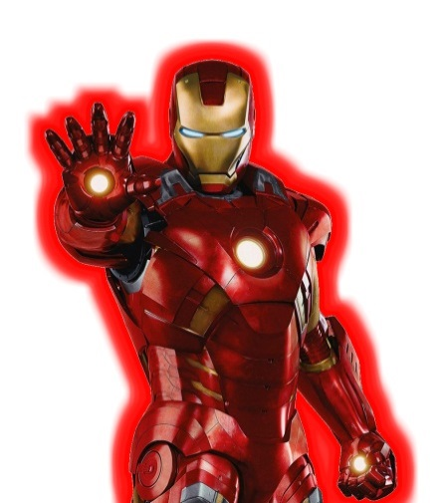
Wow, you have already beaten Batman, Hawk-girl, Thor, Black Widow, Superman and Catwoman! I hope you have practiced your 1 by 2 digit multiplication enough to beat Ironman!

15 x 5 = 18 x 6 = 22 x 4 =
26 x 6 = 32 x 4 = 17 x 8 =
90 x 2 = 43 x 2 = 55 x 7 =
65 x 4 = 77 x 3 = 88 x 3 =
33 x 3 = 13 x 5 = 20 x 9 =
___________________________________________________________
6 6 7 8 3 7
x 8 x 9 x 4

6 9 9 5 8 9
x 6 x 7 x 3

5 3 8 1 4 6
x 7 x 6 x 5

7 3 2 8 9 5
x 9 x 7 x 8

2 1 4 8 5 9
x 5 x 3 x 2

Ironman is stunned that you got this far! He tries to use some word problems to confuse you…
Ms. Pepper Potts needed to buy 11 dozen of eggs to make enough cakes for a party. How many eggs did she buy?

One dozen of ironman’s eggs cost Rm 75.00.
How much do 3 dozen costs?

Hulk scored nineteen touchdowns during the season. If each touchdown is worth 5 points, how many total points did he score?

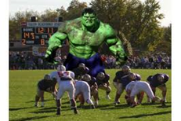
Hawkeye has 9 arrow quivers. Each quiver holds 17 arrows. How many arrows does Hawkeye have?

Tony Starks bought 6 tickets for the movie The Avengers.
Each ticket cost Rm15. How much do 6 tickets cost?

Your time
Your Points | X challenge Word problem
Time needed to beat Ironman | 3 minutes 40 seconds
Score needed to beat Ironman | 3pts on word problem/ 27 pts on multiplication challenge
