Treasure Battle
Can you find all of your partner’s treasure before they find yours? Take turns to call out co-ordinates, if your partner has a piece of treasure at that co-ordinate they have to tell you what it is. Record the position of your partner’s treasure below using the co-ordinate. REMEMBER: “Along the corridor, up the stairs”, we write co-ordinates in brackets like this: e.g. (A,7)
Picture | Name | Position
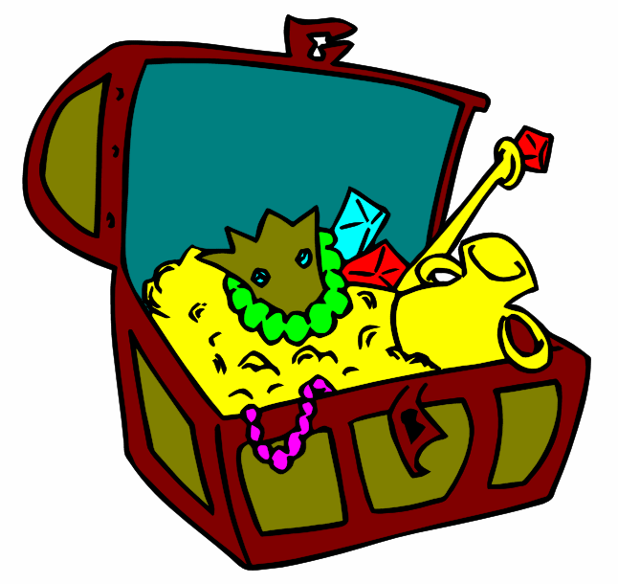 | Open treasure chest
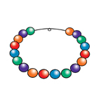 | Morgana’s necklace
 | Mixed jewels
 | The Pendragon Diamond
 | Merlin’s magic ring
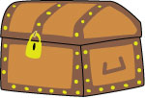 | Locked chest
 | Key to the castle
 | Ruby
 | Uther’s crown
 | Chest of coins

