**Did you know?**

Spain is part of the Iberian Peninsula. Major landforms include the Andalusian Plain, Cantabrian Mountains, the Pyrenees, Maseta Central Plateau, Sistema Central Mountains, the Sierra de Guadalupe Mountains, and the Canary Islands.

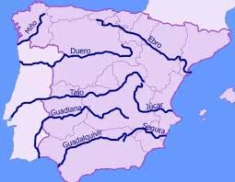

During the Autumn Term, Year 6 children will use their existing knowledge of ‘Weather’ vocabulary to produce a weather forecast, thinking carefully about their audience. They will begin to use a bilingual dictionary to support them in identifying vocabulary linked to geographical features.

la ciudad / las ciudades (the town/city - towns/cities)Bilbao, Pamplona, Barcelona, Madrid, Valencia, Granada, Cádiznorte (north)

sur (south)

este (east)

oeste (west)en la costa (on the coast)

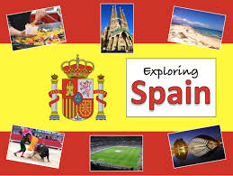

**Year 6 Knowledge Organiser Autumn Term Spanish**

**Important Vocabulary**

¿Qué tiempo hace hoy? (What’s the weather like today?)

¿Qué tiempo va a hacer? (What is the weather going to be like?

Va a hacer calor (It is going to be warm)

va a nevar (It is going to snow)

va a llover (It is going to rain)

Los continentes (coninents)

los ríos del mundo (The rivers of the world)