**Year 6 Knowledge Organiser Spring Term Spanish**

10- diez 70- setenta

20- veinte 80- ochenta

30- treinta 90- noventa

40- cuarenta 100- cien

50- cincuenta 200- doscientos

60- sesenta 300- trescientos

We recognise that Year 6 is a particularly full year, and that the pressures of assessments in English and Maths often make it difficult to devote as much time to Spanish at various points in the year. For that reason we have allocated the Spring Term as a time for children to reflect upon their Spanish learning and to revisit topics with which they feel less confident. This will allow more time for Year 6 children to focus on other curriculum areas if necessary. Children may enjoy researching some of the fantastic festivals Spain has to offer.

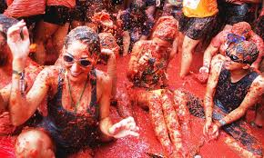

**Did you know?**

Spain is the country of fiestas and festivals! Every village, no matter how small, has its own, unique celebrations. Ever felt like throwing a tomato at someone? At the [Tomatina](https://www.spain-holiday.com/Bunol/articles/valencias-la-tomatina-the-worlds-biggest-food-fight) in **Buñol,** you can! This crazy tradition started 70 years ago, and now on every last Wednesday of August, thousands of people throw tomatoes at each other during the most fun event of the year.

La Tomatina is probably one of the most famous Spanish festivals, but is actually part of a larger celebration; it marks the end of an entire week of parades, parties, fairs and street markets. It is so original and so fun that people visit Spain just to take part in it.