[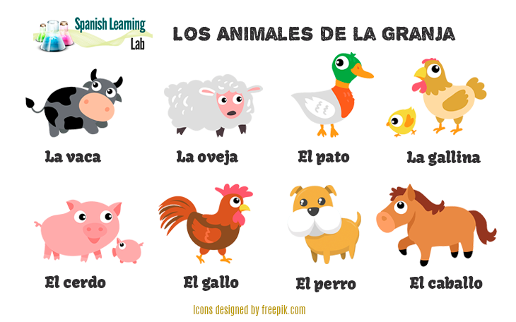](https://www.google.co.uk/url?sa=i&url=https%3A%2F%2Fwww.spanishlearninglab.com%2Ffarm-animals-spanish%2F&psig=AOvVaw1XOsXU-eL-EGRhf2dMR7t3&ust=1587554761692000&source=images&cd=vfe&ved=0CAIQjRxqFwoTCIDt2L-0-egCFQAAAAAdAAAAABAD)

Adjetivos (Adjectives)

lento(a) (slowly)

rápido(a) (quickly)

pequeño(a) (small)

tímido(a) (quiet)

grande (big)

fuerte (strong)

feroz (fierce)

[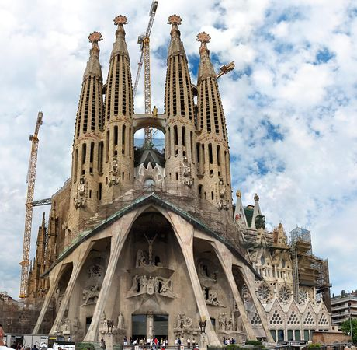](https://kids.kiddle.co/Image:Sagfampassion.jpg)

**Important Vocabulary**

Animales (Animals)

el león (lion)

el gallo (rooster)

el canguro (kangaroo)

el pez (fish)

el elefante (elephant)

el burro (donkey)

el pájaro (bird)

el cisne (swan)

la tortuga (tortoise)

la gallina (hen)

During the Summer Term, Year 4 children will begin to write a description of animals using adjectives. They will recognise and apply simple adjectival agreements. They will perform a role play, focusing on correct pronunciation.

**Interesting Fact-**La Sagrada familia in Spain is a large Roman Catholic church in Barcelona. When it is completely finished, it will be the tallest religious building in Europe.

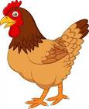

**Did you know?**

Only two of Spain's cities have a population of more than one million: the capital, Madrid, and Barcelona.

**Year 4 Knowledge Organiser Summer Term Spanish**