Our Lady and St Edwards Knowledge Organiser | Year 2 - Art | Autumn | Pottery
Information about the Artists/Sculptors |  | Key Vocabulary
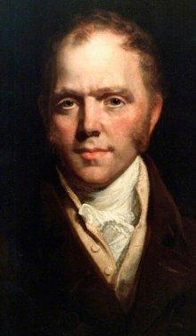  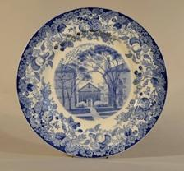  Name: Josiah Wedgewood  Life: 12 July 1730 - 3 January 1795  Country of Birth: Stoke on Trent  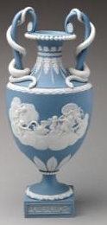  Style: Pottery  Media: Ceramics  Period: Neoclassicism  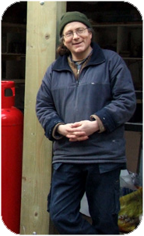  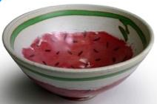  Name: Chris Barnes  Country of Birth: London  Style: Pottery  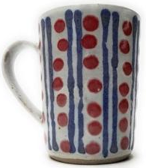  Media: Ceramics  Period: Contemporary |  | - Ceramics: a term given to any artwork produced using clay.  - Clay: Moist sticky earth. Liquid clay is called slip.  - Pottery: Objects shaped from moist clay and hardened by heat.  - Modelling: Working clay into a shape or form.  - Scoring: Cutting or scratching the surface, used to join parts of a pot e.g. a handle.  - Firing: Applying heat to harden clay in a large oven called a kiln.  - Glaze: A coating of coloured liquid glass applied to ceramics between firing.  - Hollowing: Removing the inside of a solid.  - Pinching: Squeezing between the thumb and a finger  - Coiling: Fixing rings of clay on top of each other.  - Thrown vessels: Any ceramics where a kick or electric wheel is used to produce the arts work.  - Slab: A flat evenly cut/rolled layer.  - Wedging & Kneading: Squeezing or pressing together using the hands & fingers.
Some Key Questions: |  | Books, internet sites and places to visit
- How old is pottery? When was it first created?  - What are the uses of pottery?  - Do we use pottery today? What do we use it for?  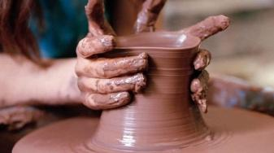  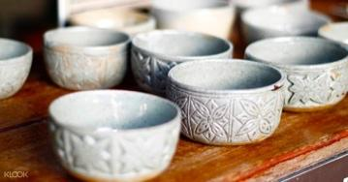  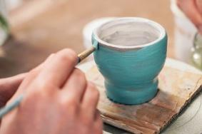  - What is the difference between ceramics and pottery? |  | Ceramics for Kids Book  https://www.youtube.com/watch?v=Vc3HSohIdNw  Visit: The Williamson Art Gallery

