1.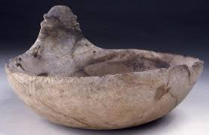 2. 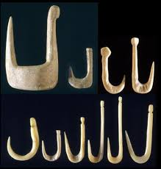 3. 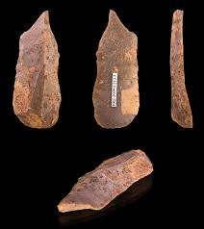

4.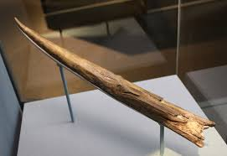 5.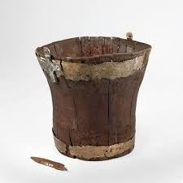 6. 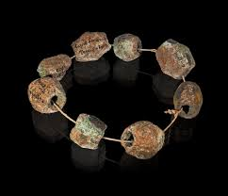

|  |  |  |
| --- | --- | --- |
| What do you think this artefact is? | What do you think it is made from? | Who do you think would have used this artefact? |
| 1. |  |  |
| 2. |  |  |
| 3. |  |  |
| 4. |  |  |
| 5. |  |  |
| 6. |  |  |