Pupil Premium 2019- 2020

Use of Pupil Premium
Background
The Pupil Premium is a government policy which allocates additional funding for children in receipt of Free School Meals, Looked After children and Forces children. The Pupil Premium is provided in order to support these pupils in reaching their potential.
At Our Lady and St Edward’s we intend to use this funding to narrow the gap in the attainment between the children who qualify for Pupil Premium and those who do not.

Pupil Premium Grant Expenditure 2019 – 2020

Number of pupils and pupil premium grant (PPG) RECEIVED
Total number of pupils on roll | 477 F1 to Y6
Total number of pupils eligible for PPG | (Ever 6 - 172)
Looked After children PPG | 3 (£2300 × 3)
Amount of PPG received per pupil | £1320
Total amount of PPG receive | £237,600

Priorities for spending Pupil Premium Grant

Whole School

Inclusion Team  Assistants to the Educational Psychologist £31,936  MEAS £1,495  Polish Teacher £6,700  Speech Therapist £4,330  Speech and Language Support £24,460  Admin Support £14,227  Counsellor £4,340  Educational Psychologists £21,500  SENCO £13,840  Achievement Mentor £16,470  Family Support Worker £23,560 | £162,858
The Inclusion Team includes an educational psychologist, 2 assistants to the educational psychologist, speech therapist, specialist SEN teacher, specialist language teacher, Polish teacher, achievement mentor, experienced counsellor, Family Support Worker, attendance officer and specialist TAs.

*EAL children are supported by our Polish teacher and the extra support we purchase from MEAS.

*The team support families who struggle with routines, behaviour and settling into school at the start of the day. They provide additional one to one activities after meeting the family at the main entrance to enable pupils to have time to orientate themselves into school and share concerns, anxieties and aspirations.
*The two assistant educational psychologists work under the supervision of Dr Richard Skelton and Dr Lee Randall, our Education Psychologists. They support pupils in a wide range of activities, programmes and interventions including: ELSA, Time to Talk, Superflex, socially speaking, starving the angry gremlin, volcano in my tummy, starving the anxiety gremlin, the incredible flexible you Coping Power, working memory training self-esteem and confidence, sensory exercises and developing awareness of sensory issues.

*We provide a range of cognitive programmes including: working memory training, attention and listening and precision teaching.

* The achievement mentor, family support worker and attendance officer support the Pupil Premium (PP) children and their families in a range of different ways including: completing forms (benefits, housing, admission, applications for employment etc.), attending meetings (outside agencies, health/educational professionals), home visits, picking up/dropping off pupils, investigating any parental concerns or worries, developing attendance, social and behaviour programmes for individual pupils.

*The family support worker arranges a range of activities during the school holidays for children and their parents / carers on a drop in basis. All activities / snacks and resources are provided free of charge to families. Family support worker also holds regular meetings including coffee mornings to enable parents / carers the opportunity to meet others and to gain access to a range of different types of support.

*The school counsellor supports individual pupils who are experiencing emotional difficulties and struggling to cope either in school or at home. She provides advice and support for parents and gives telephone or face to face support. Pupils have one to one meetings in a calm, positive and safe atmosphere where they can have high quality support.

*The specialist language teacher and speech therapist support pupils in a range of activities and programmes including: Wellcomm Programme, Phonological Awareness Training (PAT), PP Pupils are engaged in extra phonics activities to strengthen their speech and language and access to the wider Curriculum.

Curriculum | £17,000
Resources and visits are supplemented by the grant to enable children to engage in a wide range of high quality activities and visits. The curriculum is rooted in our locality and written by our staff for our pupils. This means that the curriculum is relevant, meaningful, exciting and rich in educational visits, visitors and experiences. This is particularly important to our PP children. We review the curriculum annually and we involve our pupils in the evaluation to ensure that it remains relevant, exciting and enjoyable.

Additional Facilities and resources | £18,000
We have a school mini-bus to transport the pupils, free of charge, to a range of venues and places including: parks, beaches, local countryside, museums, art galleries, places of worship, Liverpool (water front, Beatles etc.), local landmarks (Hamilton Square, Mersey docks etc.) and special events, festivals, sports etc.) These experiences include termly visits from a travelling theatre company, cinema visits, treat trips and a whole school visit to the annual pantomime. The school funds some of the activities, visits and trips to ensure that all pupils have wide, enjoyable, stimulating, fun and educational experiences.

Support for individual pupils to access a wide range of activities and opportunities | £20,050
* All PP children have contributions for visits reduced by 50% or are given free places, especially if there are several children in the family.

* PP children have additional support timetabled for one afternoon for each year group across the whole school. This provides opportunities for high quality social interaction, language development, building self-confidence, esteem and resilience.

* There is a wide range of extra school activities which provide exciting, fun, educational, sporting and enjoyable experiences for pupils. Our two sports coaches are tasked with ensuring that PP children regularly attend a range of different clubs across the whole school. Limited family resources, low aspirations and ambition can be overcome by using the extra funding through Pupil Premium to provide PP children with the experiences and opportunities which others take for granted.

*Childcare is kept at an affordable cost to enable a range of families to access high quality provision for social and economic reasons. This supports families in returning to work and gives children a wide range of experiences.

* All PP children receive a free school uniform each year from our school uniform supplier. This increases their self-esteem as they look smart and reduces the financial burden on the families. This encourages a strong home/ school relationship, setting the tone from the start of the year.

School Library | £13,000
Our librarian has raised the profile of reading and encouraged a love of books across the whole school. She deliberately targets PP children and encourages them to take books home regularly and supports them at lunch and break times. The librarian meets with parents, attending meetings, encouraging parents to use the well-stocked school library.

*The school library is open to pupils and parents before and after school daily to encourage families to use the library and choose books from our comprehensive stock.

Additional support within class, intervention and after school | £80,000
* Additional classroom staff enable the children to be taught in smaller groups across the school for all Curriculum areas.

*Additional staff are deployed during the afternoons to support all pupils with specific focus on PP children in a range of activities including intervention and precision teaching.

*We offer extra support to PP children in Foundation, Key Stage 1 and 2 who are not meeting their targets in English and Maths during the afternoons.

* Additional tuition after school and during lunchtimes is in small groups or one to one supports learning, confidence with a focus on social and communication skills for identified pupils. This strategy enables PP children to make accelerated progress and improve attainment.

Support for Parents | £6,500
The Inclusion Team support families in a variety of different ways which is vital as it enables parents to make significant and sustained contribution to their child’s overall development. Support for parents / carers include liaison with external agencies including Health, Social Care and Housing.

Total | £317,408  £79,808  additional

What was the impact of Pupil Premium last year?
The Inclusion Team has a particular regard to supporting PP children in a range of different ways including: academic, social, self-esteem, self- confidence, attendance and family circumstances. They provide focussed support after consultation with classroom based staff, ensuring individual and groups of pupils receive tailored support and learning programmes to maximize progress and reduce barriers. They identify and target specific PP children and their families to enable a holistic and concentrated support package with home and school united in meeting their complex and often wide ranging needs. This support includes intensive speech and language programmes, cognitive and behaviour assessments with the educational psychologist, including meetings with parents and specific, individual learning and behaviour programmes.

The counsellor and achievement mentor concentrate on improving self-esteem, self-confidence and dealing with social problems including: drugs, alcohol and domestic violence. This support is invaluable as it is the first step in sharing deep rooted problems and allowing other agencies to become involved. Parents and pupils feel valued and supported by having an avenue to talk about their worries in a safe and supportive environment.

The strategies implemented by school have had a significant impact upon the achievement and wider development of disadvantaged pupil across the school. Pupils are confident in lessons, behaviour is excellent and pupils relish new challenges. The excellent adult/pupil ratio means that pupils are taught in small groups by highly experienced and effective staff. PP children are enabled to make accelerated progress. The progress of each pupil is measured half-termly against challenging targets. Under- achievement being identified quickly and support is provided to ensure that the pupil is able to accelerate their progress and achieve their individual targets.

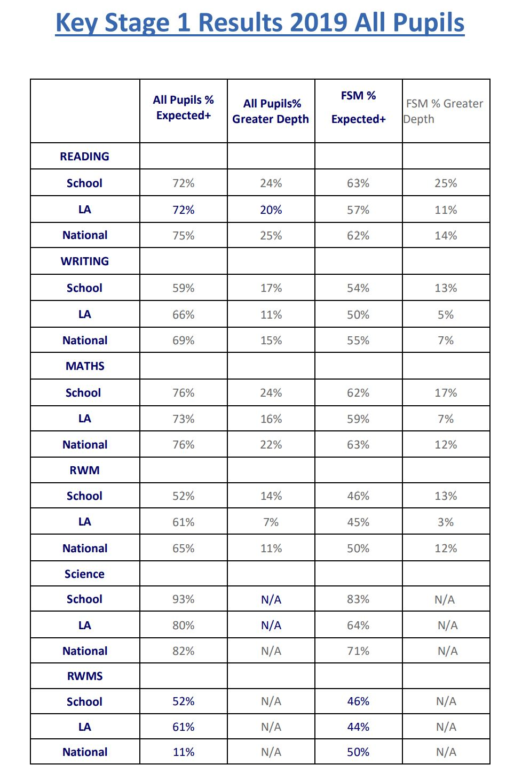

Key Stage 2 Results 2019 All Pupils

 | All Pupils %  Expected+ |  | Scaled Score |  | Higher Standard All Pupils% |  | Progress
READING | 2018 | 2019 | 2018 | 2019 | 2018 | 2019 | 2018 | 2019
School | 88 | 88.1 | 106.6 | 107.2 | 23 | 40.7 | +2.7 | +5.18
LA | 73 | 69.2 | 104.7 | 103.5 | 25 | 22.8 | -0.1 | -0.7
National | 75 | 73.1 | 105.0 | 104.4 | 28 | 26.9 |  | +0.03
WRITING |  |  |  |  |  | GDS
School | 96 | 83.1 |  |  | 25 | 6.8 | +4.0 | +1.16
LA | 75 | 75.1 |  |  | 16 | 14.4 | -0.4 | -0.9
National | 78 | 78.4 |  |  | 15 | 20.1
MATHS
School | 74 | 81.4 | 103.3 | 104.1 | 25 | 20.3 | +0.4 | +1.17
LA | 71 | 74.9 | 103.6 | 104.3 | 21 | 24.0 | -0.5 | -0.5
National | 76 | 78.6 | 104.3 | 105.1 | 23 | 26.6 |  | +0.03
RWM
School | 65 | 69.5 | 104.8 |  | 14 | 3.4
LA | 60 | 60 | 104.1 |  | 8 | 7.8
National | 64 | 64.8 |  |  | 10 | 10.5
GPS
School | 93 | 86.4 | 107.1 | 106.9 | 30 | 35.6
LA | 76 | 75 | 105.4 | 105.3 | 30 | 30.3
National | 78 | 78 | 106.1 | 106.3 | 34 | 35.7
SCIENCE
School | 100 | 84.8
LA | 79 | 80
National

