Our Lady and St Edwards Knowledge Organiser | Year 1- Art | Spring | Seascapes
Some important facts |  | Key Vocabulary
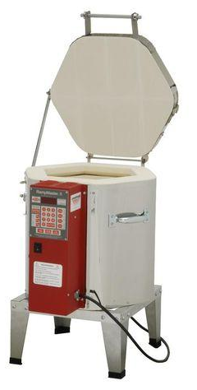  Three types of clay to be used in Ceramics:  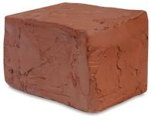  - Earthenware  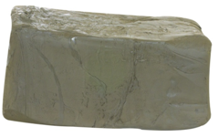  - Stoneware  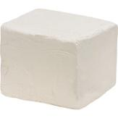  A kiln is a large oven which applies heat to the clay to harden it. Each clay needs to be set at a different temperature.  - Porcelain |  | - Ceramics - Ceramic art is art made from ceramic materials, including clay. It may take forms including artistic pottery, including tableware, tiles, figurines and other sculpture.  - Clay - Moist sticky earth. Liquid clay is called slip.  - Modelling - Working clay into a shape or form.  - Firing - Applying heat to harden clay in a large oven called a kiln.  - Seascape - A seascape is a photograph, painting, or other work of art which depicts the sea, in other words an example of marine art.  - Sculptor - A sculptor shapes clay, stone, marble, wood, and other materials (even ice and potatoes) into two- or three-dimensional art. Some sculptors carve out stone or marble or weld pieces of metal together into freestanding statues. Sculptors also carve into walls or other surfaces, a technique called relief.  - Sculpture - Sculpture, an artistic form in which hard or plastic materials are worked into three-dimensional art objects.
Key Questions
- What is a Seascape/ Ceramic Art?
- Which materials are used to create ceramics?
- How are ceramics recorded?
- Can you name a well-known ceramic sculptor?
Key Facts about the Artist |  | Books, internet sites and places to visit
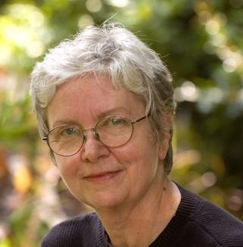  Name: Alice Ballard  Life: 16 June 1945 (age 74 years old)  Country of Birth: South Carolina, USA  Style: Ceramics Sculptor  Media: Ceramics |  | http://aliceballard.com/home-1#home  https://www.underwatersculpture.com/

